# Saluda County Emergency Management Division Natural Hazard Mitigation Plan

**Saluda County Natural Hazard Mitigation Plan**

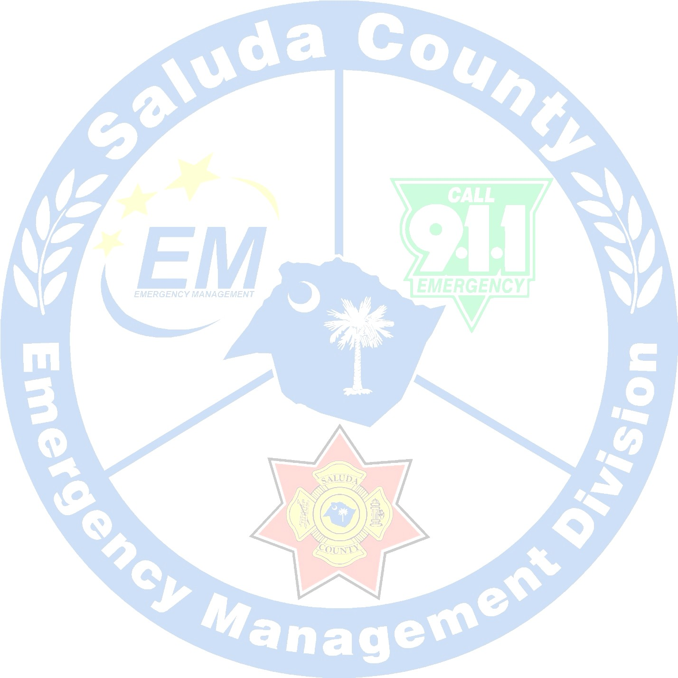

## For Official Use Only

Saluda County Emergency Management Division Natural Hazard Mitigation Plan

**(Page Left Blank Intentionally)**

Saluda County Emergency Management Division Natural Hazard Mitigation Plan

## Contents

Contents i

List of Maps iii

List of Tables ix

List of Figures ix

Record of Changes x

1. Introduction 1
   1. Background 1
   2. Mission/Purpose 2
2. Planning Process 2
   1. Overview of Hazard Mitigation Planning 2
   2. Hazard Mitigation Planning Committee 3
   3. Coordination with neighboring communities and local and regional agencies 3
   4. Public Involvement 4
   5. Plan Adoption 4
3. County and Municipal Profiles 4
   1. Saluda County 4
   2. Town of Saluda 9
   3. Town of Ridge Spring 9
   4. Town of Ward 9
4. Hazard Identification and Risk Assessment 9
   1. Introduction 9
   2. Social Vulnerability 10
   3. Specific Hazards 12
      1. Drought 12
      2. Earthquake 12
      3. Flooding 13
      4. Hail 16
      5. Hurricane/Tropical Storm 16
      6. Severe Thunderstorms and Lightning 17

Saluda County Emergency Management Division Natural Hazard Mitigation Plan

* + 1. Tornado 17
    2. Wildfire 20
    3. Winter Weather 20
  1. All-Hazard Vulnerability 20

1. Capabilities Assessment 23
   1. Planning and Regulatory 23
   2. Administrative and Staffing 25
   3. Financial 26
   4. Education and Outreach 27
2. Hazard Mitigation Strategy 27
   1. Hazard Mitigation Goals 27
   2. Evaluating and Prioritizing Mitigation Actions 28
   3. Mitigation Action Plan Implementation 29
3. Monitoring, Evaluating, and Updating the Plan 30
   1. Monitoring and Evaluation 30
   2. Plan Maintenance Cycle 30

Saluda County Mitigation Action Plan 31

Town of Saluda Mitigation Action Plan 36

Town of Ridge Spring Mitigation Action Plan 38

Appendix 1: Adoption Resolutions 41

Appendix 2: Declared Disasters 45

Appendix 3: Historical Events (1960 – 2020) 46

Appendix 4: Planning Committee Agendas, Minutes and Sign-In Sheets 50

Appendix 5: Public Hearings 60

Appendix 6: Public Notices 62

References 65

Saluda County Emergency Management Division Natural Hazard Mitigation Plan

## List of Maps

Map 1 - Location of Saluda County within South Carolina 6

Map 2 - Saluda County Population Distribution by Fire Service Coverage Area 7

Map 3 - Location of Municipalities Within Saluda County 8

Map 4 - Saluda County Social Vulnerability 2018-2023 11

# Saluda County Emergency Management Division Natural Hazard Mitigation Plan

Map 5 - Saluda County 100 - Year Flood Probability

# Saluda County Emergency Management Division Natural Hazard Mitigation Plan

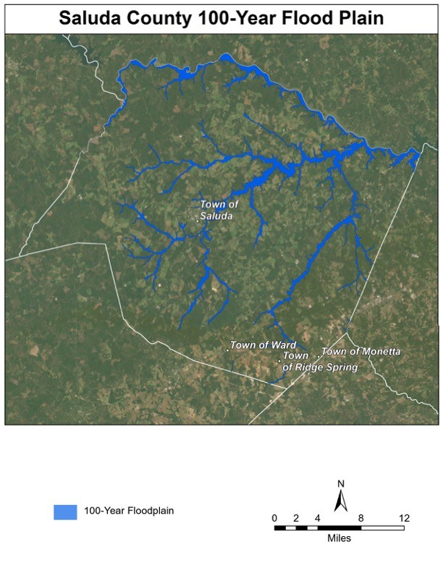

Saluda County Emergency Management Division Natural Hazard Mitigation Plan

.................................................................................................................................................................... 15

# Saluda County Emergency Management Division Natural Hazard Mitigation Plan

Map 6 - Saluda County Tornado Events 1950-2020

# Saluda County Emergency Management Division Natural Hazard Mitigation Plan

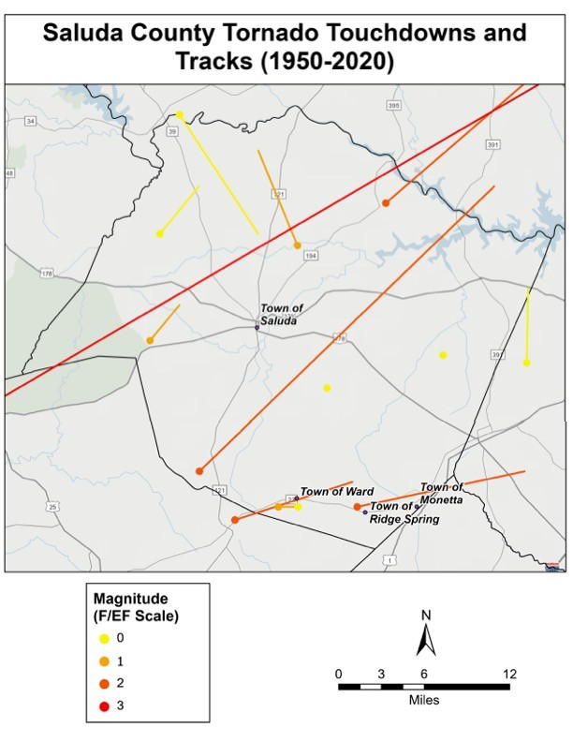

Saluda County Emergency Management Division Natural Hazard Mitigation Plan

.................................................................................................................................................................... 19

## List of Tables

Table 1 - Hazard Mitigation Planning Committee Membership 3

Table 2 - Natural Hazard Vulnerability Analysis 21

Table 3 - Scientific Scales for Calculating Maximum Probable Extent 22

Table 4 - Natural Hazard Place Vulnerability and Maximum Probable Extent 22

Table 5 - Existing Planning Mechanisms 23

Table 6 - Administrative Capabilities 25

Table 7 - Staffing Capabilities 26

Table 8 - Potential Funding Source Eligibility 27

Table 9 - Plan Update Cycle 30

## List of Figures

Figure 1 - Earthquake Energy Equivalents 13

Figure 2 - Saffir-Simpson Scale 17

Figure 3 - Enhanced Fujita Scale and Expected Damages 18

Saluda County Emergency Management Division

Natural Hazard Mitigation Plan

## Record of Changes

|  |  |  |  |
| --- | --- | --- | --- |
| **Rev.** | **Date** | **Page** | **Change** |
|  |  |  |  |
|  |  |  |  |
|  |  |  |  |
|  |  |  |  |
|  |  |  |  |
|  |  |  |  |
|  |  |  |  |
|  |  |  |  |
|  |  |  |  |
|  |  |  |  |
|  |  |  |  |
|  |  |  |  |
|  |  |  |  |
|  |  |  |  |
|  |  |  |  |
|  |  |  |  |
|  |  |  |  |
|  |  |  |  |
|  |  |  |  |
|  |  |  |  |

## Introduction

### Background

The Disaster Mitigation Act of 2000, an amendment of the Robert T. Stafford Disaster Relief and Emergency Assistance Act (Public Law 93-288) of 1988, set forth the mission to establish a national disaster hazard mitigation program to:

* + 1. *Reduce the loss of life and property, human suffering, economic disruption, and disaster assistance costs resulting from natural disasters; and*
    2. *Provide a source of pre-disaster hazard mitigation funding that will assist States and local governments (including Indian tribes) in implementing effective hazard mitigation measures that are designed to ensure the continued functionality of critical services and facilities after a natural disaster1.*

The Act also outlines the mandate that local governments shall develop and maintain a plan that shall:

1. *Describe actions to mitigate hazards, risks, and vulnerabilities identified under the plan; and*
2. *Establish a strategy to implement those actions2.*

On April 18, 2001, the Saluda County Council passed a resolution creating the Saluda County Preparedness Agency (later renamed the Saluda County Emergency Management Division), whose director is charged with the development and maintenance of all emergency plans for Saluda County, including this Natural Hazard Mitigation Plan. As Saluda County shares many of the same goals and needs as the municipalities within the County and, as such, maintains a close relationship with these municipalities, it was decided early in the mitigation planning process that a single, multi-jurisdictional plan was the most appropriate course of action for all parties involved.

As the hazard mitigation planning committee began to review the 2010 plan in preparation for the 2015 planning cycle, it was determined that a new plan would be more appropriate than an update to the previous plan, as the previous plan did not appropriately reflect the mitigation strategy and goals of the jurisdictions and was not well aligned with other Saluda County and municipal plans. This plan was updated in 2020 and again in late 2024 for the 2025 planning cycle.

In accordance with the Disaster Mitigation Act of 2000 and the Saluda County Resolution dated April 18, 2001, Saluda County has updated the Saluda County Natural Hazard Mitigation Plan, replacing the previous plan adopted in 2020, to meet all federal guidelines for mitigation planning, risk assessment, and grant program management.

### Mission/Purpose

This plan outlines Saluda County’s strategy for all natural hazard mitigation goals, actions, and initiatives. The Saluda County Natural Hazard Mitigation Plan is the result of the systematic evaluation of the nature and extent of vulnerability to the effects of natural hazards present in Saluda County and includes the actions needed to minimize future vulnerability to those hazards. It sets forth the policies, procedures, and philosophies that are used to establish and implement hazard mitigation activities within the county. Effective and consistent implementation of this plan is crucial to the hazard mitigation program and the county’s efforts to reduce or eliminate the threat of future disasters. This plan incorporates all changes associated with implementing the Federal/State hazard mitigation program, including the applicable sections of the Disaster Mitigation Act of 2000. Overall administration of the hazard mitigation program shall be the responsibility of the Saluda County Emergency Management Division and participating municipalities.

## Planning Process

### Overview of Hazard Mitigation Planning

Mitigation planning is a critical component of a successful emergency management program. A comprehensive mitigation plan forms the foundation for a community’s long-term strategy to reduce disaster losses, protect lives and property, and break the repetitive cycle of disaster damages, injuries, and loss of life. A core assumption of hazard mitigation is that a pre-disaster investment can significantly reduce the demand for post-disaster assistance. Further, the adoption of mitigation actions enables local residents, businesses, and industries to more quickly recover from a disaster, getting the economy back on track sooner and with less interruption. Mitigation planning is an integral step to becoming a less vulnerable, more resilient county capable of fully recovering after a natural hazard event.

The benefits of mitigation planning go beyond reducing hazard vulnerability. Measures such as the acquisition or regulation of land in known hazard areas can help achieve multiple community goals, such as preserving open space, maintaining environmental health, and enhancing recreational opportunities. It creates a framework for risk-based decision-making that will continue to not only protect the current infrastructure and populations but prevent future generations and development from being significantly impacted by natural hazards. We cannot control nature, but we can control how we grow physically, economically, and socially in the future.

Updates to the Saluda County Natural Hazard Mitigation Plan began in late 2024 with a review of the 2020 plan by the Hazard Mitigation Committee. The plan was updated to data from incidents occurring after the 2020 update, as well as updated mitigation actions. In the summer of 2024, the formal update process began for the 2025 plan update cycle. The plan update process was interrupted briefly by the county’s response to Hurricane Helene but was resumed in January

2025. The Hazard Vulnerability Analysis, Risk Assessment, and Capabilities Assessment were updated to reflect the incorporation of new data and changes in capabilities. Mitigation actions were updated to reflect progress and new ideas.

During the planning process, the hazard mitigation planning committee reviewed and incorporated existing plans, studies, reports, and technical information into this plan, including Saluda County and Town of Saluda’s Comprehensive Plans, the South Carolina Hazard Mitigation Plan, and data and analysis from the University of South Carolina’s Hazard Vulnerability Institute and the National Oceanic and Atmospheric Administration’s National Climatic Data Center.

The planning process utilized in the update of this plan is outlined below:

1. Continue the hazard mitigation planning committee
2. Update risk assessment
3. Update capabilities assessment
4. Update natural hazard mitigation action plan
5. Adopt and implement plan

### Hazard Mitigation Planning Committee

As part of the development of this new plan, the planning committee membership was developed to include representatives from each jurisdiction represented in the plan. The current committee membership is reflected in **Table 1**.

**Table 1 - Hazard Mitigation Planning Committee Membership**

|  |  |
| --- | --- |
| **Name** | **Organization** |
| Joshua Morton | Saluda County EMD Director* |
| Sandra Padget | Saluda County Director |
| Andy Coleman | Saluda County Roads and Bridges Superintendent |
| Archie Hill | Police Chief, Town of Saluda |
| Gerry Grenier | Police Chief, Town of Ridge Spring |
| Larry Lange | Mayor, Town of Ward |
| Jill Warren | Saluda County EMD Assistant Director |

*\*Serves as chair of the committee*

### Coordination with neighboring communities and local and regional agencies

Since developing the first Saluda County Hazard Mitigation Plan, Saluda County has coordinated the plan with the South Carolina Emergency Management Division, the South Carolina Department of Natural Resources, the University of South Carolina’s Hazard and Vulnerability Research Institute, the Town of Saluda, the Town of Ridge Spring, the Town of Ward, and the Saluda County Water and Sewer Authority.

### Public Involvement

Throughout the planning process, the public has been invited to participate in the development of this plan in accordance with 44 CFR 201.6 (b)3. Public notices, placed in the Saluda Standard- Sentinel and the Greenwood Index-Journal and on the Saluda County website, can be found in

**Appendix 6: Public** Notices**.** On April 10th, 2025, a draft copy of the plan was placed on the Saluda County website for public review and comment. Additionally, a public hearing was held on May 12, 2025, and a second public hearing was held on .

### Plan Adoption

Saluda County, the Town of Ridge Spring, and the Town of Saluda will formally adopt the 2025 Saluda County Hazard Mitigation Plan upon SCEMD and FEMA review and upon receipt of approval pending adoption (APA) status. These three jurisdictions will formally adopt the Saluda County Hazard Mitigation Plan in public meetings. Upon adoption, a copy of the resolutions will be placed in **Appendix 1: Adoption Resolutions**. A sample resolution is currently included in this appendix. Because the Town of Ward has no paid staff members and does not have the ability to fund mitigation projects, the Town will not formally adopt the plan and will rely on Saluda County to assist in addressing needs related to hazard mitigation. However, the Town of Ward has been a key participant in the planning process and has been fully integrated into the plan.

### Plan Evaluation

The planning committee will evaluate the effectiveness of the plan and suggest updates to the plan throughout the five-year planning cycle. The plan’s effectiveness will be determined by measuring proposed and completed mitigation actions against changes to the jurisdictional hazard vulnerabilities.

## County and Municipal Profiles

### Saluda County

Saluda County is located near the geographic center of South Carolina. It is bordered on the north by Newberry County and the Saluda River, on the east by Lexington County, to the south by Edgefield and Aiken Counties, and to the west by Greenwood County. The total land area in Saluda County is approximately 453 square miles. **Map 1** illustrates the location of Saluda County within the State of South Carolina.

The population of Saluda County, based on the 2020 Census, was 18,855, showing a decrease of 1,020 over the preceding decade4. **Map 2** illustrates how this population is distributed throughout Saluda County. There has been no significant development in Saluda County since the previous plan was published.

The County contains three incorporated municipalities: **Saluda (county seat), Ridge Spring,** and **Ward**. Saluda County also contains the following unincorporated communities: Amick Grove, Delmar, Hollywood, Mayson, Merchant, Mount Willing, Owdoms, Richland Springs, and the Circle. Additionally, small portions of the incorporated towns of Batesburg-Leesville (Lexington County) and Monetta (Aiken County) also lie within Saluda County. **Map 3**illustrates the location of incorporated municipalities within Saluda County. There has been no significant development in any of these jurisdictions since the previous plan was published.

**Map 1 - Location of Saluda County within South Carolina**

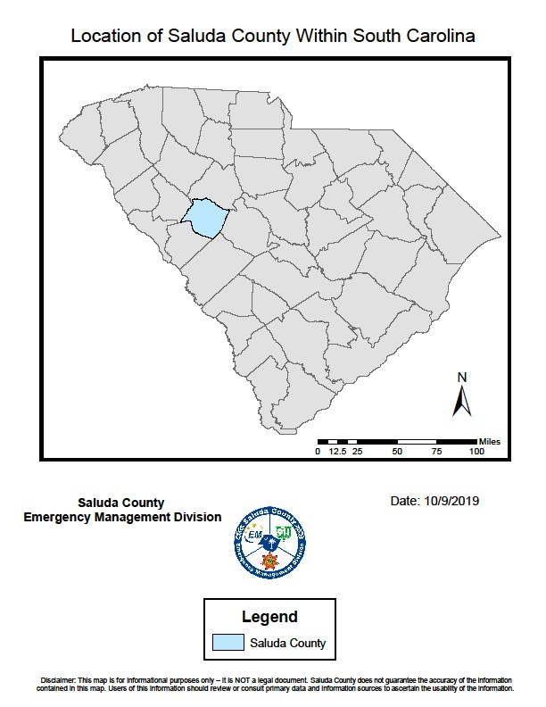

**Map 2 - Saluda County Population Distribution by Fire Service Coverage Area**

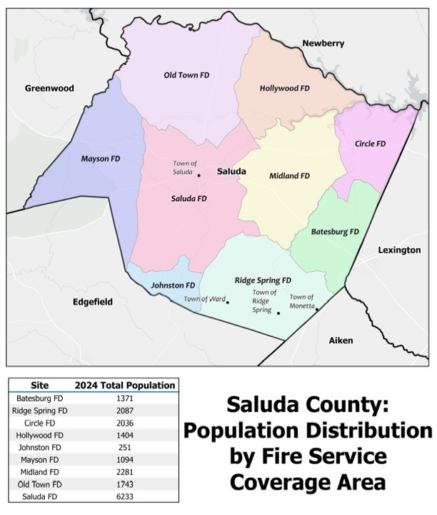

**Map 3 - Location of Municipalities Within Saluda County**

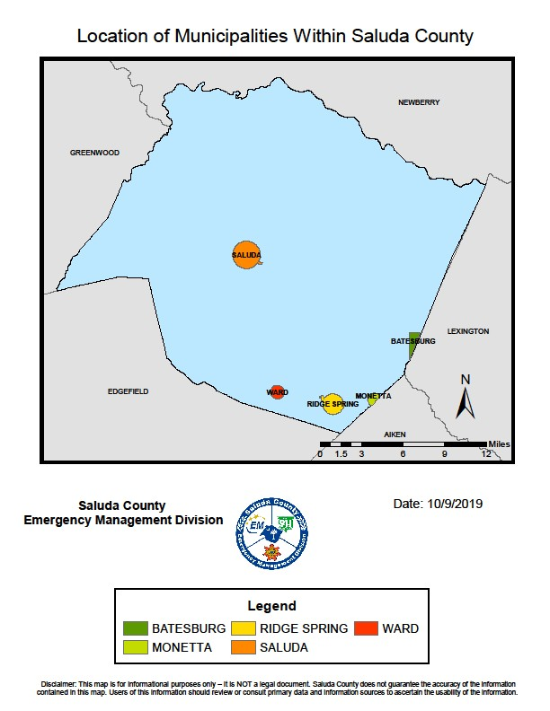

### Town of Saluda

The Town of Saluda is located near the geographic center of Saluda County and serves as the county seat. Saluda is the largest municipality in Saluda County, surrounded by unincorporated and largely undeveloped areas. The total land area of the Town of Saluda is approximately 3.24 square miles. The population of the town, based on the 2020 Census, was 3,114, marking a decrease of 451 over the preceding decade5.

### Town of Ridge Spring

The Town of Ridge Spring is located along the southern border of Saluda County. Its total land area is approximately 1 square mile, and it is surrounded primarily by agricultural or undeveloped land. The population of the town, based on the 2020 Census, was 579, marking a decrease of 158 over the preceding decade6.

### Town of Ward

The Town of Ward is located along the southwestern border of Saluda County. Its total land area is approximately 0.5 square miles, and it is surrounded primarily by agricultural or undeveloped land. The population of the town, based on the 2020 census, was 121, marking an increase of 30 over the preceding decade7.

## Hazard Identification and Risk Assessment

### Introduction

Saluda County, like all jurisdictions, is vulnerable to a wide range of natural hazards. This risk assessment aims to analyze the major hazards that affect Saluda County. Some hazards impact the county more than others. A complete analysis has been performed for those natural hazards that are most likely to cause adverse impacts to people and property within the borders of Saluda County and municipalities.

For the majority of the analyses, the best available data was collected through 2022. Data for the risk assessment was derived primarily from the Spatial Hazard Events and Loss Database for the United States (SHELDUS) and the Storm Events Database from the National Climatic Data Center (NCDC), as well as from a variety of other sources and from state and local agencies. These data sources examine the historical hazard frequency of occurrence (risk) and losses.

Each natural hazard type is given a section of its own, providing a brief overview of the hazard, the maximum probable extent, and notable historical occurrences, if applicable. Lastly, a section on all-hazard vulnerability that examines historical frequency, risk, and losses is included.

Additional information regarding historical occurrences utilized in the hazard vulnerability analysis can be found in **Appendix 3: Historical Events****.**

### Social Vulnerability

Social vulnerability is considered in this document to analyze the underlying characteristics of the population that either attenuate or exacerbate the effects of hazard events. The Social Vulnerability Index (SoVI) “measures the social vulnerability of U.S. counties to environmental hazards.” “The index synthesizes 30 socioeconomic variables, which the research literature suggests contribute to a reduction in a community’s ability to prepare for, respond to, and recover from hazards.”8 Key social indicators that consistently appear in the literature as influencing pre- impact preparedness and post-event response and recovery include attributes such as socioeconomic status (wealth, education, occupation), age (elderly populations and young children are more vulnerable); gender; race and ethnicity; employment and employment sector; and special needs populations. However, it is not just the proportion of residents in these broad categories that is important; instead, it is how race, socioeconomic status, and gender interact to produce socially vulnerable populations.

SoVI synthesizes these socioeconomic variables into multiple dimensions and sums the values to produce the overall score for the particular spatial unit (e.g. county, census tract) of interest. The resulting data allows emergency planners to begin to understand, at sub-county levels, the characteristics of the population and how these are increasing or decreasing vulnerability in order to better identify where resources and attention should be directed for planning and mitigation9.

Based on 2019 National County Data, Saluda County has a social vulnerability score of 0.02, ranking 20th out of 46 South Carolina Counties and with a national percentile of 47%. This means that Saluda County has a slightly higher than average social vulnerability8.

Within Saluda County, Social vulnerability varies from medium on the eastern border to high in the central and western areas. **Map 4** illustrates Saluda County's social vulnerability.

**Map 4 - Saluda County Social Vulnerability 2018-2023**

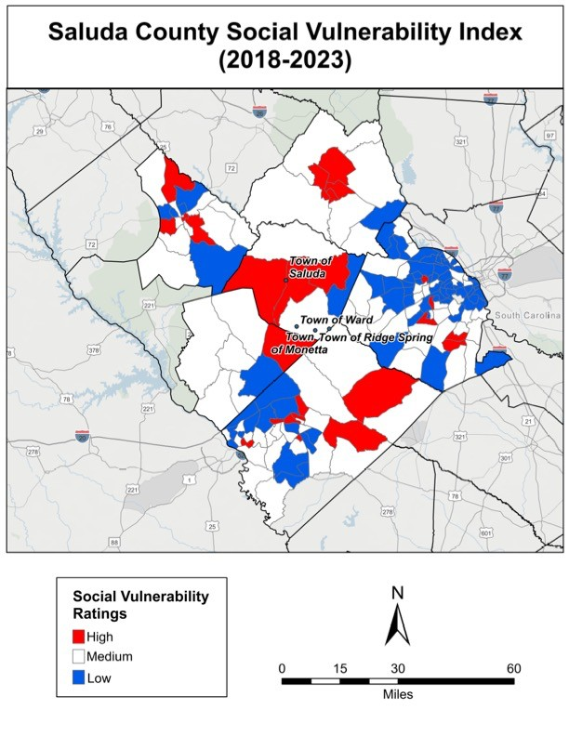

### Specific Hazards

#### Drought

Periodic droughts are documented throughout Saluda County’s historical climate record. Drought can be measured by departures of precipitation from a long-term average over an extended time. Due to the largely agricultural nature of Saluda County, drought conditions have the potential to have a significantly negative impact on the County’s economy. There are 8 loss-causing drought events on record for Saluda County between 1960 and 2022, resulting in crop damages of $11,636,281.73 and property damages of $5,907,579.8310. In 2011, Saluda County experienced extreme drought (-4.0 and below on the Palmer Drought Severity Index) in the months of January, February, August, September, October, and December11.

#### Earthquake

An earthquake is ground shaking caused by a sudden movement of rock in the Earth’s crust. Such movements occur along faults, which are thin zones of crushed rock separating blocks of crust. When one block suddenly slips and moves relative to the other along a fault, the energy released creates vibrations called seismic waves that radiate up through the crust to the Earth’s surface, causing the ground to shake12.

According to the United States Geological Survey, the magnitude of an earthquake is determined from the logarithm of the amplitude of waves recorded by seismographs. Adjustments are included for the variation in the distance between the various seismographs and the epicenter of the earthquakes. On the Richter Scale, magnitude is expressed in whole numbers and decimal fractions. For example, a magnitude 5.3 might be computed for a moderate earthquake, and a strong earthquake might be rated as a magnitude 6.3. Because of the logarithmic basis of the scale, each whole number increase in magnitude represents a tenfold increase in measured amplitude; as an estimate of energy, each whole number step in the magnitude scale corresponds to the release of about 31 times more energy than the amount associated with the preceding whole number value13. **Figure 1** illustrates the energy equivalents of various magnitudes.

The only major recorded earthquake to be felt in Saluda County was the Charleston Earthquake of 1886 (estimated magnitude of 7.3). Saluda County is located in a medium- risk earthquake zone and has experienced a few minor earthquakes.

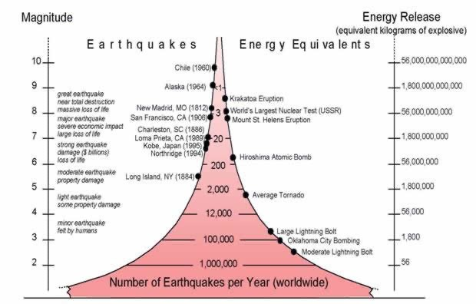

\**Magnitude measured based on the Richter Scale*

*Source:* [*http://www.geology.ar.gov/geohazards/eq_geninfo.htm*](http://www.geology.ar.gov/geohazards/eq_geninfo.htm)

**Figure 1 - Earthquake Energy Equivalents**

#### Flooding

Flooding is defined by the NFIP as a general and temporary condition of partial or complete inundation of two or more acres of normally dry land area or of two or more properties or the collapse or subsidence of land along the shore of a lake or similar body of water as a result of erosion or undermining caused by waves or currents of water exceeding anticipated cyclical levels that result in a flood as defined above14.

Saluda County has streams that are subject to flooding during periods of heavy rainfall. The majority of these streams, however, have sufficient depth to their banks to prevent flooding that will endanger human lives or real property. The Saluda River, which marks the northern boundary of Saluda County, and Lake Murray have no significant history of flooding.

According to the National Climatic Data Center, the largest recorded flooding event in Saluda County since 1960 was on September 3, 2000. During this event, six inches of water were recorded in Ridge Spring, closing some roads and washing over creek beds15.

Identification of floodplain areas within the county and the incorporated municipalities was based on the most recent Flood Insurance Rate Maps (FIRM) produced by FEMA. These maps display the locations of all major bodies of water within the county and delineate the

100-year floodplain boundaries. Based on these maps, 100-year floodplains exist only in the unincorporated areas of Saluda County and within the municipal limits of the Town of Saluda. However, while the other municipalities do not have mapped floodplains, they are not immune to flooding. According to the Saluda County Comprehensive Plan, nuisance flooding impacts many roads throughout the county and all municipalities due to poorly designed and maintained drainage systems.

#### Notable Historical Occurrences:

**October 3, 2015:** Beginning on October 3, 2015, Saluda County and other areas of South Carolina experienced a significant rainfall event that resulted in both flash and riverine flooding. Saluda County was declared for public assistance under federal disaster DR-4241 due primarily to the significant loss of county roads during the event.

##### National Flood Insurance Program (NFIP)

In 1968, Congress created the NFIP to help provide a means for property owners to protect themselves financially. The NFIP offers flood insurance to homeowners, renters, and business owners if their community participates in the NFIP. Participating communities agree to adopt and enforce ordinances that meet or exceed FEMA requirements to reduce the risk of flooding16. These ordinances are designed to guide development away from high-flood risk areas and to minimize the impact of structures building is special flood hazard areas by requiring that they do not obstruct the natural flow of floodwaters.

#### Participation

Both Saluda County and the Town of Saluda are active participants in the NFIP and have continued to comply with its requirements and objectives. These jurisdictions have adopted the NFIP Ordinance, adopted the FIRM Rate Map, enforce floodplain regulation, and continue to manage construction and development within floodplain areas. Both jurisdictions utilize contracted building code vendors to enforce the ordinance. If the jursidiction is overwhelmed, additional resources will be requested through the State Coordinating Office or through an agreement entered into with another community. The towns of Ridge Spring and Ward have no mapped special flood hazard areas and, therefore, are not participants in the NFIP.

#### Repetitive Loss

There are no documented repetitive loss properties within the boundaries of Saluda County.

**Map 5 - Saluda County 100 - Year Flood Probability**



#### Hail

Hail can occur year-round and can happen anywhere because it derives from severe thunderstorms17. Hail is a form of precipitation consisting of ice pellets that form when updrafts of thunderstorms carry water droplets to the freezing level of the atmosphere18. Hail can vary greatly in size, with larger sizes capable of causing property damage and injury or even death to livestock and humans.

The largest hail event in Saluda County occurred on April 24, 1999. A supercell thunderstorm moved southeast through Saluda County and produced baseball-sized hail (upwards of 2.75”) along its entire path. The damage path was about three miles wide. Two people were injured by the hail when they were caught outside in the middle of plowing their fields19.

#### Hurricane/Tropical Storm

While Saluda County is considered an inland county and, as a result, is less susceptible to tropical systems than counties located closer to the South Carolina coast, the County can be, and in fact has been, on numerous occasions, impacted by these storm systems. The worst-case scenario for Saluda County with regards to a tropical system would be for a large, strong hurricane (Category 4 or 5) to make landfall along the southern border of South Carolina and maintain strength while moving inland quickly. Fortunately, most of the storms that have impacted Saluda County have approached from the southeast and have weakened considerably prior to impacting the County.

#### Notable Historical Occurrences:

**September 27, 2024:** On September 27, 2024, Saluda County was significantly impacted by Hurricane Helene. There were three fatalities in the county, including two volunteer firefighters. Saluda County was declared for both Public and Individual Assistance under federal disaster DR- 4829. This is the most significant disaster in Saluda County History, with dozens of homes reporting major damage or destroyed status. The county experienced widespread power outages lasting up to three weeks and an overwhelming amount of debris. Additionally, several public buildings sustained substantial damage.

*Source:* [*http://www.boqueteweather.com/saffir_simpson_hurricane_scale.htm*](http://www.boqueteweather.com/saffir_simpson_hurricane_scale.htm)

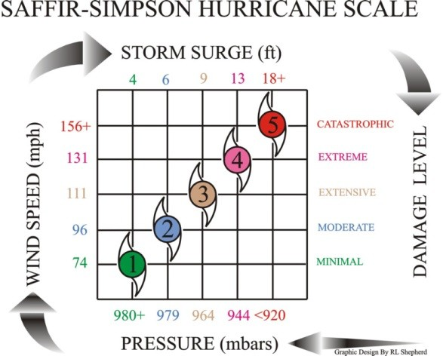

**Figure 2 - Saffir-Simpson Scale**

#### Severe Thunderstorms and Lightning

A thunderstorm is a rainstorm event during which thunder is heard. This thunder is audible because lightning causes the air to heat and expand rapidly. Therefore, all thunderstorms have lightning20.

A thunderstorm is classified as severe when at least one of the following occurs: wind speeds exceed 58 miles per hour, tornadoes spawn, or hail exceeds 1.00 inches in diameter21. About 10% of yearly thunderstorm events in the United States are classified as severe.

Lightning can cause injury and death. If thunder can be heard, lightning is present, and the best way to protect against lightning is to avoid it. The National Weather Service advises people to find an enclosed building to shelter in while staying away from electronics, showers, sinks, and bathtubs. Fully enclosed automobiles are relatively safe because, if struck, the electricity will flow around the outside of the car.

The strongest recorded thunderstorm to strike Saluda County occurred on July 31, 2011. The storm produced heavy rains and wind damage, with winds greater than 70 knots22.

#### Tornado

A tornado is a violent windstorm characterized by a twisting, funnel-shaped cloud extending to the ground. Tornadoes may form at any time of the year. However, the peak time of year for these events occurs in the spring and early summer months of March through June, particularly during late afternoon and early evening. Tornados are measured using the Enhanced Fujita Scale (EF), which replaced the Fujita Scale in 2007. **Figure 3** illustrates the

types of damage expected based on the EF rating. **Map 6** shows recorded tornado events within Saluda County from 1950 to 2020.

#### Notable Historical Occurrences

**March 13, 1955:** A category F2 tornado killed two and injured 10, causing approximately $250,000 in property damage.

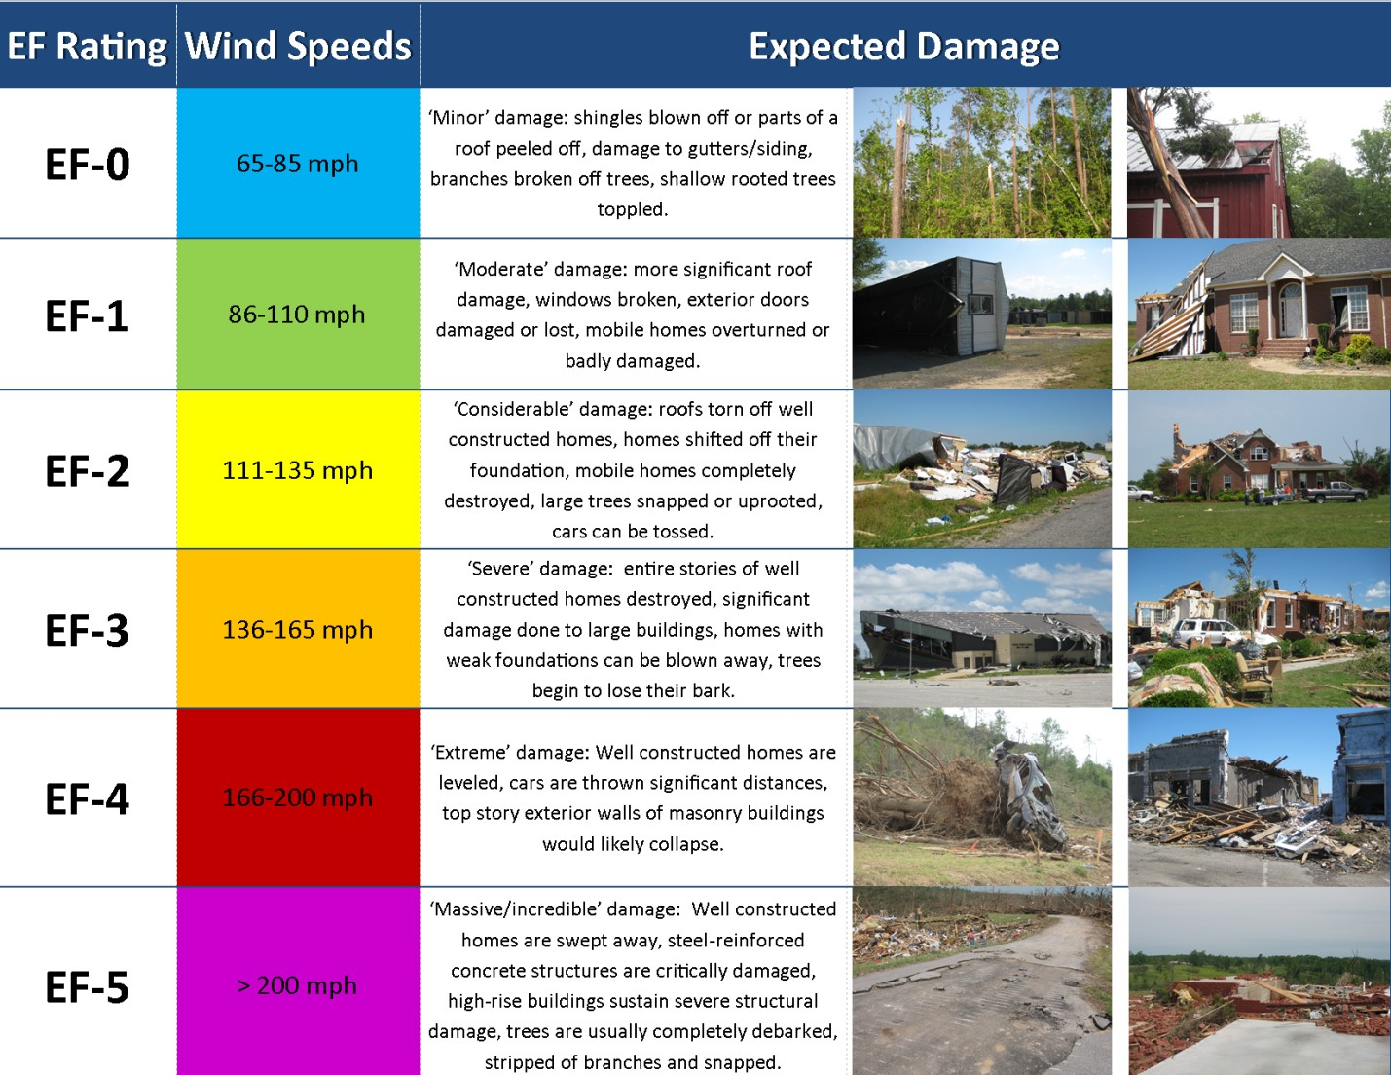

**November 22, 1992:** Saluda County was impacted by two tornadoes, registering F2 and

F3 respectively. One person was killed and 9 others were injured23.

**May 7, 1998:**

The Town of Ward was impacted by an F1 tornado, causing approximately $50,000 in property damage. No injuries or deaths

were reported23.

*Source:* [*http://www.srh.noaa.gov/images/ohx/EF-Ratings.png*](http://www.srh.noaa.gov/images/ohx/EF-Ratings.png)

**Figure 3 - Enhanced Fujita Scale and Expected Damages**

**Map 6 - Saluda County Tornado Events 1950-2020**



#### Wildfire

The South Carolina Forestry Commission defines wildfires as any type of forest, grass, brush, or outdoor fire that is not controlled or managed24. In Saluda County, approximately 30 such fires occur each year, accounting for an average of 140 acres burned annually. Fire danger season is highest in late winter and early spring due to dead or dormant vegetation increasing the fuel supply.

It should be noted, however, that while approximately 30 wildfires occur each year, most of these are small and do not cause significant property damage. As a result, the risk of wildfire in Saluda County is relatively low.

#### Winter Weather

Winter storms and winter weather kill dozens of Americans each year and create a variety of hazards, including cold exposure, vehicle accidents, the improper use of heating devices, and other winter weather-related incidents. Hazards associated with winter weather also include strong winds, extreme cold, flooding, heavy snow, and ice storms. Additional concerns related to winter weather include electrical and communications outages25.

#### Notable Historical Occurrences

**January 22-29, 2000:** Heavy snowfall was reported throughout the County. School and governmental facilities were forced to close. Saluda County was included in Major Disaster Declaration DR-131326.

**January 26-30, 2004:** A severe ice storm resulted in road and business closures. School and governmental facilities were forced to close. Saluda County was included in Major Disaster Declaration DR-150926.

**February 10-14, 2014:** A severe ice storm resulted in road and business closures. School and governmental facilities were forced to close. This storm produced ¼ inch of ice and 2-4 inches of snow across the county. Saluda County was included in Major Disaster Declaration DR- 416626.

### All-Hazard Vulnerability

While nearly all hazards can theoretically occur within the jurisdictions included in this plan, it is vital to identify those hazards that are (1) most likely to occur and (2) most likely to cause significant loss. In order to identify these hazards, the Hazard Mitigation Planning Committee analyzed data on loss-causing events from 1960 through 2022. After compiling this data, it was determined that a simple formula could be created to rank these hazards. Each hazard type was assigned two scores. The first is a probability score based on the future probability (% chance per year). The hazards were ranked in order from 2-10 (as there were nine identified hazards included in the analysis), with the most likely event to occur (Severe Thunderstorm) receiving a score of 10, and the least likely to occur (Earthquake) receiving a score of 2.

The second score is based on annualized losses. Again, hazards were ranked from 2 to 10, with the highest annualized losses (Winter Storm) receiving a score of 10 and the lowest annualized losses (Earthquake) receiving a score of 2. The probability score and annualized loss score were combined to determine an overall hazard score and the overall hazard rankings, which was then used to rank the hazards.

*It should be noted that Saluda County does not currently have finalized data related to Hurricane Helene. Once this data is added, it is anticipated that Hurricane/Tropical Storm will be ranked substantially higher than this table reflects.

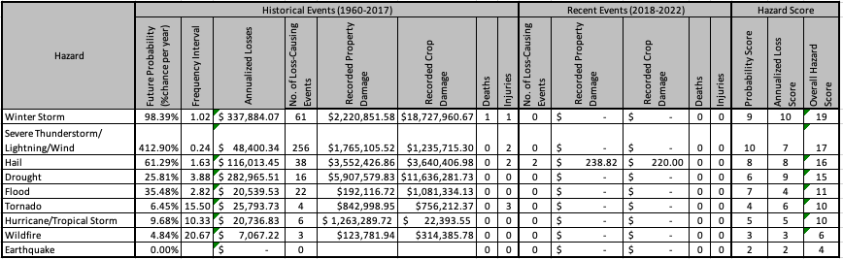

**Table 2** includes data relevant to loss-causing events from 1960 through 2020, and illustrates both the probability of occurrence and the anticipated losses for included hazard types. The rightmost three columns indicate each identified hazard’s probability, annualized loss, and overall hazard scores.

**Table 2 - Natural Hazard Vulnerability Analysis**

Data Source: SHELDUSv17

**Table 4** illustrates both place vulnerability (hazard location) and the maximum probable extent for each hazard type addressed in the natural hazard vulnerability analysis. With regards to maximum probable extent, guidance from worksheet 5.1 of the Local Mitigation Planning Handbook27 was utilized to assign each hazard a maximum probable extent for each jurisdiction as follows (numbers in parenthesis are utilized in **Table 4** to symbolize the maximum probable extent):

**No Threat (0):** The jurisdiction is not susceptible to the listed hazard.

**Weak (1):** Limited classification on scientific scale, slow speed of onset or short duration of event, resulting in little to no damage.

**Moderate (2):** Moderate classification on scientific scale, moderate speed of onset or moderate duration of event, resulting in some damage and loss of services for days.

**Severe (3):** Severe classification on scientific scale, fast speed of onset or long duration of event, resulting in devastating damage and loss of services for weeks or months.

**Extreme (4):** Extreme classification on scientific scale, immediate onset or extended duration of event, resulting in catastrophic damage and uninhabitable conditions.

**Table 3 - Scientific Scales for Calculating Maximum Probable Extent**

*Source: Local Mitigation Planning Handbook (Page A-30)*

**Table 4 - Natural Hazard Place Vulnerability and Maximum Probable Extent**

*\*While neither the Town of Ridge Spring nor the Town of Ward have mapped floodplains, both towns are susceptible to localized*

*flooding issues from time to time during periods of heavy rainfall.*

|  |  |  |  |  |  |
| --- | --- | --- | --- | --- | --- |
| **Hazard** | **Scale/Index** | **Weak** | **Moderate** | **Severe** | **Extreme** |
| **Drought** | Palmer Drought Severity Index | -1.99 to +1.99 | -2.00 to -2.99 | -3.00 to -3.99 | -4.00 and below |
| **Earthquake** | Modified Mercalli Scale | I to IV | V to VII | VII | IX to XII |
| Richter Magnitude | 2, 3 | 4, 5 | 6 | 7, 8 |
| **Hurricane Wind** | Saffir-Simpson Hurricane Wind Scale | 1 | 2 | 3 | 4, 5 |
| **Tornado** | Fujita Tornado Damage Scale | F0 | F1, F2 | F3 | F4, F5 |

|  |  |  |  |  |  |  |  |  |  |
| --- | --- | --- | --- | --- | --- | --- | --- | --- | --- |
| **Jurisdiction** | **Winter Storm** | **Severe Thunderstorm/**  **Lightning/ Wind** | **Hail** | **Drought** | **Flood** | **Tornado** | **Hurricane/**  **Tropical Storm** | **Wildfire** | **Earthquake** |
| **Saluda County** | 3 | 2 | 2 | 4 | 3 | 3 | 3 | 4 | 2 |
| **Town of Saluda** | 3 | 2 | 2 | 4 | 3 | 3 | 3 | 4 | 2 |
| **Town of Ridge Spring** | 3 | 2 | 2 | 4 | 2* | 3 | 3 | 4 | 2 |
| **Town of Ward** | 3 | 2 | 2 | 4 | 2* | 3 | 3 | 4 | 2 |

## Capabilities Assessment

The purpose of this section of the plan is to examine current mitigation capabilities within Saluda County and the municipalities. Local mitigation capabilities are existing authorities, policies, programs, and resources that reduce hazard impacts or that could be used to implement hazard mitigation activities27. The four areas that will be addressed in this assessment are (A) Planning and Regulatory, (B) Administrative and Staffing, (C) Financial, and (D) Education and Outreach.

### Planning and Regulatory

Planning and regulatory capabilities are the plans, policies, codes, and ordinances that prevent and reduce the impact of hazards. **Table 5** indicates existing planning mechanisms in the four jurisdictions represented by this plan.

**Table 5 - Existing Planning Mechanisms**

|  |  |  |  |  |  |  |
| --- | --- | --- | --- | --- | --- | --- |
| **Jurisdiction** | **Comprehensive Plan** | **Capital Improvement Plan** | **Building Codes** | **Flood Hazard Ordinance** | **Zoning Ordinance** | **Emergency Operations Plan** |
| **Saluda County** | Yes | No | Yes | Yes | No | Yes |
| **Town of Saluda** | Yes | No | Yes | Yes | Yes | No* |
| **Town of Ridge Spring** | No | No | No* | No | No | No* |
| **Town of Ward** | No | No | No | No | No | No* |

#### Comprehensive Plan

*\*Covered by Saluda County’s plan, code, or ordinance.*

Comprehensive planning is the process of planning a future community, or the guidance and shaping of the expansion of a current community, in an organized manner and with an organized layout, taking into account such considerations as convenience for its inhabitants, environmental conditions, social requirements, recreational facilities, aesthetic design, and economic feasibility. Such planning includes a study of present requirements and conditions as well as projections for the future and often includes proposals for implementing the plan28. Both Saluda County and the Town of Saluda have adopted comprehensive plans. Comprehensive plans are an essential part of hazard mitigation, as they can be utilized to ensure that various hazards are considered as future development is planned, ensuring that development is not centered in high-hazard zones (such as floodplains), and that essential and emergency services are made available in areas where development is to occur. Saluda County is currently updating our comprehensive plan and will consider the ideas, information, and strategy of this mitigation plan as part of that update.

#### Capital Improvement Plan

According to the National Capital Planning Commission, capital improvement plans provide a link between the visions articulated by comprehensive plans and annual capital expenditure budgets29. From a hazard mitigation standpoint, capital improvement plans allow jurisdictions to layout potential facilities, infrastructure, and other improvements that could significantly impact the community’s ability to avoid or recover from a variety of hazards. This plan also incorporates future upgrades, improvements, and replacement of current facilities and infrastructure. The capital improvement planning process impacts the hazard mitigation planning process by identifying shortfalls in current facilities and infrastructure, as well as identifying facilities and infrastructure that could be beneficial during a disaster. None of the jurisdictions this plan covers have a capital improvement plan. As such, this has been identified as a future action in the mitigation action plan.

#### Building Codes

Building codes are perhaps one of the greatest tools the local government has with regard to hazard mitigation. Building codes are defined as the minimum legal requirements established or adopted by a government to ensure the structural safety of buildings30. Through adopting and enforcing building codes, local governments can ensure that structures are built to withstand various hazards that threaten the community. The 2018 edition of the International Building Code (IBC) has been adopted by both Saluda County and the Town of Saluda. The Town of Ridge Spring has adopted the 2018 edition but contracts with Saluda County for building code enforcement.

#### Flood Hazard Ordinance

Floodplains are an important asset to any community, providing vital natural functions such as temporary storage of floodwaters, moderation of peak flood flows, maintenance of water quality, and groundwater recharge, among many others. It is essential, however, to manage development within the floodplains to ensure the protection of people, property, and infrastructure and to minimize the expenditure of public money for costly flood control projects and rescue and relief efforts associated with flooding31. Flood hazard ordinances are utilized at the local level to reduce losses associated with development within floodplain areas. Both Saluda County and the Town of Saluda have flood hazard ordinances, as both mapped floodplains.

#### Zoning Ordinance

Zoning is defined as legislative action, usually on the municipal level, which separates or divides municipalities into districts for the purpose of regulating, controlling, or in some way limiting the use of private property, and the construction and/or structural nature of buildings erected within the zones or districts established32. Zoning ordinances are utilized for hazard mitigation purposes in much the same way as the comprehensive plan, except that, unlike the comprehensive plan, zoning ordinances are legally enforceable laws adopted by the jurisdiction. Currently, the Town of Saluda has enacted a zoning ordinance.

#### Emergency Operations Plan

The Emergency Operations Plan serves as the basic blueprint for responding to emergencies. This plan describes how people and property will be protected; details who is responsible for carrying out specific actions; identifies the personnel, equipment, facilities, supplies, and other resources available; and outlines how all actions will be coordinated33. The Emergency Operations Plan is utilized in the hazard mitigation planning process to help identify response capabilities for each hazard identified. Inversely, the Natural Hazard Mitigation Plan is utilized in the emergency operations planning process to help identify hazards most likely to affect the community, as well as potential response capability shortfalls.

### Administrative and Staffing

The jurisdictions covered under this plan have limited administrative and staffing capabilities for carrying out hazard mitigation policies and projects. This is largely due to their size and overall staffing shortages within local government.

The following tables demonstrate the administrative and staffing capabilities of each jurisdiction included in this plan:

**Table 6 - Administrative Capabilities**

|  |  |  |  |  |
| --- | --- | --- | --- | --- |
| **Jurisdiction** | **Legislative Council** | **Planning Commission** | **Mitigation Planning Committee** | **Mutual Aid Agreements** |
| **Saluda County** | Yes | Yes | Yes* | Yes |
| **Town of Saluda** | Yes | Yes | Yes* | Yes |
| **Town of Ridge Spring** | Yes | No | Yes* | Yes |
| **Town of Ward** | Yes | No | Yes* | No |

*\*All Jurisdictions are represented on the Saluda County Hazard Mitigation Planning Committee*

**Table 7 - Staffing Capabilities**

|  |  |  |  |  |  |  |  |  |
| --- | --- | --- | --- | --- | --- | --- | --- | --- |
| **Jurisdiction** | **Emergency Manager** | **Building Codes Official** | **Floodplain Administrator** | **Community Planner** | **Civil Engineer** | **GIS**  **Coordinator** | **Roads/ Streets Superintendent** | **Grant Writer** |
| **Saluda County** | FT | FT | FT | Contract | No | FT | FT | FT |
| **Town of Saluda** | No1 | PT | FT | FT2 | No | No1 | FT | FT2 |
| **Town of Ridge Spring** | No1 | No1 | N/A | No | No | No1 | No | No |
| **Town of Ward** | No1 | No | N/A | No | No | No1 | No | No |

### Financial

*FT denotes full-time position, PT denotes part-time position 1Indicates that municipality relies on Saluda County for this service 2Indicates that the Town Administrator serves in this function*

The ability to take mitigation actions in any jurisdiction is closely related to the amount of money available to implement policies and projects, as well as the amount of money necessary to take a specific mitigation action. The costs associated with various mitigation actions varies greatly, and funding eligibility from various sources can vary based on many factors, including jurisdiction size, median household income, and project to be completed.

As Saluda County has largely an agriculturally-based economy and has a relatively small tax base, local governmental funding for hazard mitigation projects at both the county and municipal level is extremely limited. As such, Saluda County and all municipalities must rely on other funding mechanisms to complete hazard mitigation projects. **Table 8** includes a list of potential funding sources for hazard mitigation activities, and denotes each jurisdiction’s eligibility for these sources.

**Table 8 - Potential Funding Source Eligibility**

|  |  |  |  |
| --- | --- | --- | --- |
|  | **Jurisdiction Eligibility** | | |
| **Potential Funding Source** | **Saluda County** | **Town of Saluda** | **Town of Ridge Spring** |
| **Capital Improvement Project Funding** | Yes | Yes | Yes |
| **Authority to levy taxes for specific purposes** | Yes | Yes | Yes |
| **Incur debt through general obligations bonds and/or special tax bonds** | Yes | Yes | Yes |
| **Community Development Block Grant (CDBG)** | Yes | Yes | Yes |
| **Hazard Mitigation Grant Program (HMGP)** | Yes | Yes | Yes |
| **Pre-Disaster Mitigation Program (PDM)** | Yes | Yes | Yes |

### Education and Outreach

Education and community outreach are perhaps the most readily accessible capabilities within Saluda County and, as such, many of the activities included in the mitigation action plan are centered on utilizing these capabilities.

## Hazard Mitigation Strategy

### Hazard Mitigation Goals

Mitigation goals are general guidelines that explain what a community wants to achieve, typically in broad policy-type statements that are long term, representing visions for reducing or avoiding losses from identified hazards27. After reviewing goals published in the previous plan, the planning committee has developed a new set of goals that better reflects the intent of the mitigation program for all jurisdictions moving forward. None of the previous goals were carried over into this plan.

The planning committee has developed the following goals for mitigation planning for all jurisdictions:

**Goal #1:** Implement policies and projects designed to reduce or eliminate the impacts of hazards on people and property.

**Goal #2:** Implement policies and projects designed to reduce or eliminate disruptions to the functioning of the community’s infrastructure.

**Goal #3:** Enhance training, education, and outreach efforts focusing on the effects of hazards, the importance of mitigation, and ways to increase resiliency.

**Goal #4:** Collect and utilize data, including conducting necessary studies and analyses, to improve policymaking and identify appropriate mitigation projects.

### Evaluating and Prioritizing Mitigation Actions

Mitigation actions are defined as specific actions, projects, activities, or processes taken to reduce or eliminate long-term risk to people and property from hazards and their impacts27. The implementation of mitigation actions helps the community achieve the mission and goals established in this plan.

In order to identify potential mitigation actions, the hazard mitigation planning committee reviewed both the risk and capabilities assessments developed during the planning process. Potential actions were then developed based on brain storming sessions, a review of mitigation actions from the previous plan and mitigation plans from other jurisdictions, and a review of potential mitigation ideas published by FEMA34. The majority of the actions included are new to this plan, based on the new goals and strategies developed by the committee. There was no significant progress made on existing mitigation actions carried over from the previous plan.

After developing a list of potential mitigation actions for each jurisdiction, the committee evaluated and prioritized the most suitable mitigation actions for each jurisdiction. This evaluation was based on a variety of factors, including benefit-cost analysis and criteria outlined on worksheet 6.1 of the Local Mitigation Planning Handbook27. Not all identified potential actions are included in the final action plan because of technical feasibility, political acceptance, lack of funding, or other constraints.

The actions that have been included in the mitigation action plan have been prioritized by the Hazard Mitigation Planning Committee using the following process:

1. Analyze each item to determine which goal(s) the item addressed.
2. Analyze the number and types of hazards addressed by the action item, with priority given to items addressing multiple hazards and hazards with high overall hazard scores, as defined in the hazard vulnerability analysis.
3. Using estimated costs and required resources, conduct a benefit cost-analysis for each action item.
4. Assign each action item a priority of *High, Medium,* or *Low* as defined:
   * ***High Priority (HP)*** – Actions associated with hazards that impact the community on an annual or nearly annual basis and generate impacts to critical facilities and/or people, and/or having a high benefit-cost ratio.
   * ***Medium Priority (MP)*** – Actions associated with hazards that impact the community less frequently and do not typically generate impacts to critical facilities and/or people, and/or having a moderate benefit-cost ratio.
   * ***Low Priority (LP)*** – Actions associated with hazards that rarely impact the community and have rarely generated documented impacts to critical facilities and/or people, and/or having a low benefit-cost ratio.

### Mitigation Action Plan Implementation

The mitigation action plan identifies mitigation action items developed by the Hazard Mitigation Planning Committee with input from both internal and external agencies, as well as the public.

##### Responsible Organization

In order to clearly describe how actions will be implemented and administered, at a minimum, a specific agency, department, or position must be assigned to the action. As part of the Mitigation Action Plan, the Hazard Mitigation Planning Committee has identified a responsible organization for each action item. Some action items have multiple agencies listed as certain action items may require a substantial amount of coordination between multiple organizations.

##### Timeframes

The Hazard Mitigation Planning Committee has assigned a timeframe for each action item, based primarily on technical and economic feasibility. Each action item has been assigned a timeframe of *Short Term, Medium Term, Long Term, Ongoing,* or *Completed* as defined below:

* ***Short Term (ST)*** – Actions intended to be implemented within one to two years.
* ***Medium Term (MT)* –** Actions intended to be implemented within three to five years.
* ***Long Term (LT)*** – Actions that will require more than five years to implement.
* ***Ongoing (O)*** – Actions that have already begun implementation but have no definite ending.
* ***Completed (C)*** – Actions that have been completed.

##### Potential Funding Sources

While some hazard mitigation action items can be completed with minimal funding, the implementation of others may be dependent on funding from programs outside the jurisdiction. Keeping this in mind, the Hazard Mitigation Planning Committee has identified potential funding sources for each mitigation action item. In addition to local and state funding, the following programs have been identified as potential funding sources for hazard mitigation action items:

* FEMA Hazard Mitigation Grant Program (HMGP)
* FEMA Pre-Disaster Mitigation Grants (PDM)
* Flood Mitigation Assistance Program (FMA)
* DHS State Homeland Security Program Grant (SHSP)
* Local Emergency Management Performance Grant (LEMPG)
* CDC Hospital Preparedness Program (HPP)
* FEMA Fire Prevention and Safety Grant Program (FP&S)
* Community Development Block Grant (CDBG)
* National Oceanic and Atmospheric Administration (NOAA)

## Monitoring, Evaluating, and Updating the Plan

### Monitoring and Evaluation

Monitoring of this plan is required to ensure that the goals of Saluda County are kept current, to include monitoring which mitigation efforts are being carried out and ensuring that the plan remains in compliance with local, state, and federal requirements. The Saluda County Emergency Management Division staff is responsible for monitoring the implementation of this plan. An annual review will be conducted by the Hazard Mitigation Planning Committee to evaluate and monitor the implementation of the plan and to ensure that the goals set forth in this plan are being achieved.

### Plan Maintenance Cycle

As required by 44 CFR Part 201, this plan will be updated at least every five (5) years35. For future updates, the Saluda County Emergency Management Division, with the coordination of the Hazard Mitigation Planning Committee will continue to review the plan on an annual basis and make modifications when deemed necessary. The Hazard Mitigation Planning Committee will also evaluate the nature and magnitude of hazard events and/or community development that has changed since the plan’s implementation. Additionally, the plan will remain available for public comment on the Saluda County website, and all Hazard Mitigation Planning Committee meetings will be open to the public.

**Table 9** outlines the actions to be taken in each year of the plan update cycle.

Table 9 - Plan Update Cycle

|  |  |  |  |  |  |
| --- | --- | --- | --- | --- | --- |
| **Year** | **Review Plan** | **Review and Update Mitigation Actions** | **Update Risk Assessment** | **Update Capabilities Assessment** | **Conduct and Submit Formal Plan**  **Update** |
| 1 | X | X |  |  |  |
| 2 | X | X |  |  |  |
| 3 | X | X | X |  |  |
| 4 | X | X |  | X |  |
| 5 | X | X |  |  | X |

## Saluda County Mitigation Action Plan

|  |  |  |  |  |  |  |
| --- | --- | --- | --- | --- | --- | --- |
| **Goal(s)** | **Mitigation Action** | **Hazard(s) Addressed** | **Priority and Timeframe** | **Potential/ Current Funding Sources** | **Responsible Agency or Department** | **Milestones Achieved, Impediments to Implementation** |
| 1 | Identify facilities for emergency sheltering of citizens during and following natural disasters. | Tornados, Winter Weather, Flooding, Hurricanes and Tropical Storms, Wildfire | HP O | Local and State Funding | Saluda County EMD, American Red Cross | American Red Cross working with various facilities across the county. |
| 1 | Retrofit shelter facilities to include backup power and communication systems. | Winter Weather, Hurricanes and Tropical Storms | HP MT | HMGP, PDM, SHSP,  HPP, Local and State Funding | Saluda County EMD, Saluda County Council, Saluda County School District, Facility Owners | Seeking funding for additional retrofits. |
| 1 | Implement and enforce building and zoning codes to ensure that no new structures are built within the floodplains. | Flooding | HP O | Local and State Funding | Saluda County Building Codes | Successfully implemented. Currently maintaining. |
| 1 | Expand fire hydrant coverage into currently un-serviced areas of the county and municipalities. | Wildfire | MP O | AFG, CDBG,  Local and State Funding | Saluda County Water and Sewer Authority, Saluda CPW, Ridge Spring Public Works | Ongoing. Seeking additional funding. |
| 1 | Continue the installation of "dry" hydrants in the rural portions of Saluda County. | Wildfire | MP O | AFG, Local and State Funding | Saluda County Fire Service, Private Property Owners | Currently identifying additional sites for dry hydrants. |
| 1 | Adopt and enforce updated building code provisions to reduce earthquake damage risk. | Earthquake | LP O | Local and State Funding | Saluda County Building Codes | County has adopted most current codes and is enforcing. |

|  |  |  |  |  |  |  |
| --- | --- | --- | --- | --- | --- | --- |
| **Goal(s)** | **Mitigation Action** | **Hazard(s) Addressed** | **Priority and Timeframe** | **Potential/ Current Funding Sources** | **Responsible Agency or Department** | **Milestones Achieved, Impediments to Implementation** |
| 1 | Plan for and install an outdoor emergency siren warning system throughout the county. | Tornado | MP C | NOAA | Saluda County EMD | 9 sirens installed throughout the county in September 2009.  Will be removed in future plan update due to completion |
| 2 | Install and maintain a UPS system and generator for the county's computer systems. | Severe Thunderstorms and Lightning, Winter Weather, Hurricane/ Tropical Storm | HP C | HMGP, PDM, SHSP,  Local and State Funding | Saluda County Information Technology | The County currently has a UPS system on all systems.  Generator installed in 2016. |
| 1, 2 | Develop new and/or upgrade existing water delivery systems to eliminate breaks and leaks. | Drought, Wildfire | LP O | CDBG,  Local and State Funding | Saluda County Water and Sewer Authority, Saluda CPW, Ridge Spring Public Works | New water treatment plant opened in 2019. |
| 1, 2 | Develop a capital improvement plan, highlighting capital improvements that will help mitigate future disasters. | Winter Weather, Severe Thunderstorms and Lightning, Hail, Flood, Tornado, Hurricane/ Tropical Storm, Wildfire, Earthquake | MP O | Local and State Funding | Saluda County Council | Developed as part of the Saluda County Comprehensive Plan.  Plan will be updated as needed. |
| 1, 2 | Provide emergency power supply to all existing critical facilities. | Winter Weather, Severe Thunderstorms and Lightning, Hurricane/ Tropical Storms, Earthquake, Tornado | HP O | HMGP, PDM, SHSP,  HPP, Local and State Funding | Saluda County EMD, Saluda County Council | The county has currently installed generators at the county EOC, Dispatch Center, Communications Tower, Jail, and Coroner’s Holding Facility. Generator added at courthouse in 2016. |

|  |  |  |  |  |  |  |
| --- | --- | --- | --- | --- | --- | --- |
| **Goal(s)** | **Mitigation Action** | **Hazard(s) Addressed** | **Priority and Timeframe** | **Potential/ Current Funding Sources** | **Responsible Agency or Department** | **Milestones Achieved, Impediments to Implementation** |
| 1, 2 | Identify critical road drainage concerns throughout the county. Inspect and improve or retrofit road drainage systems. | Flooding | MP O | HMGP, PDM,  Local and State Funding | Saluda County Roads and Bridges, SC DOT | Currently working to increase size of drainage pipes under county roads as needed. |
| 3 | Conduct annual fire safety programs for children, with an emphasis on fire prevention for both structural and wildfires. | Wildfire | MP O | FP&S,  Local and State Funding | Saluda County Fire Service | An annual fire safety camp is held at the Hollywood Fire Department. Saluda County Fire Service also conducts programs in conjunction with Saluda County Schools. |
| 3 | Collect educational materials on individual and family preparedness/ mitigation measures for property owners, and display at public facilities, including libraries and county and municipal government offices. | Severe Thunderstorms and Lightning, Winter Weather, Flooding, Hurricane/ Tropical Storm, Tornado, Wildfire Earthquake | HP O | LEMPG, FP&S,  Local and State Funding Sources | Saluda County EMD | Display locations have been identified in multiple county facilities and are utilized to distribute these materials. |
| 3 | Educate children about the dangers associated with natural hazards and how to take safety precautions. | Severe Thunderstorms and Lightning, Winter Weather, Hail, Flooding, Hurricane/ Tropical Storm, Tornado, Wildfire, Earthquake | HP O | LEMPG,  Local and State Funding | Saluda County EMD | Annual programs are conducted in conjunction with Saluda County Schools. |

|  |  |  |  |  |  |  |
| --- | --- | --- | --- | --- | --- | --- |
| **Goal(s)** | **Mitigation Action** | **Hazard(s) Addressed** | **Priority and Timeframe** | **Potential/ Current Funding Sources** | **Responsible Agency or Department** | **Milestones Achieved, Impediments to Implementation** |
| 3 | Incorporate and promote social media to engage the public before, during, and after disasters. | Severe Thunderstorms and Lightning, Winter Weather, Hail, Flooding, Hurricane/ Tropical Storm, Tornado, Wildfire, Earthquake | HP O | Local and State Funding | Saluda County EMD | Saluda County EMD has successfully incorporated social media to engage the public through both Facebook and Twitter. |
| 1, 3 | Encourage agricultural interests to obtain crop insurance to cover potential losses due to drought. | Drought, Flood | MP O | Local and State Funding | Saluda County Economic Development, Clemson Extension | No significant progress reported. |
| 4 | Expand the current Geographic Information System (GIS) to incorporate current cadastral (building/parcel) data for purposes of conducting more detailed hazard risk assessments and for tracking land use patterns. | Flooding, Wildfire | MP O | Local and State Funding | Saluda County GIS | GIS has added parcel data and is working to keep this data current. |
| 4 | Expand the current Geographic Information System (GIS) to incorporate hazard related layers for the purpose of conducting more detailed hazard risk assessments. | Flooding, Tornado, Wildfire, Earthquake, Hurricane/ Tropical Storm | MP O | Local and State Funding | Saluda County GIS | Hazard layers have been added to the GIS database. GIS is working with Saluda County EMD to keep this data current. |

|  |  |  |  |  |  |  |
| --- | --- | --- | --- | --- | --- | --- |
| **Goal(s)** | **Mitigation Action** | **Hazard(s) Addressed** | **Priority and Timeframe** | **Potential/ Current Funding Sources** | **Responsible Agency or Department** | **Milestones Achieved, Impediments to Implementation** |
| 4 | Conduct Mitigation Public Opinion Surveys to determine personal preparedness and knowledge levels about hazard mitigation and garner public input for future updates to this plan. | Severe Thunderstorms and Lightning, Hail, Flooding, Drought, Hurricane/ Tropical Storm, Tornado, Wildfire, Earthquake | HP ST | LEMPG,  Local and State Funding | Saluda County EMD | No significant progress reported. |
| 2, 3 | Educate and encourage citizens to take measures to conserve water. | Drought | MP O | Local and State Funding | Saluda County Water and Sewer Authority, Saluda CPW, Ridge Spring Public Works | This has been successfully implemented and is ongoing. |
| 1, 2 | Implement an inspection program for all high hazard and significant hazard dams located within Saluda County | Flooding | MP O | HMGP, PDM,  Local and State Funding, Private Funding | SCDHEC, Dam  Owners | New Action added November, 2015.  SCDHEC is working with dam owners. |
| 1, 2 | Ensure that all dams located within Saluda County are regularly and properly maintained and repaired as necessary | Flooding | MP O | HMGP, PDM,  Private Funding | SCDHEC, Dam  Owners | New Action added November, 2015 |

## Town of Saluda Mitigation Action Plan

|  |  |  |  |  |  |  |
| --- | --- | --- | --- | --- | --- | --- |
| **Goal(s)** | **Mitigation Action** | **Hazard(s) Addressed** | **Priority and Timeframe** | **Potential/ Current Funding Sources** | **Responsible Agency or Department** | **Milestones Achieved, Impediments to Implementation** |
| 1 | Identify facilities for emergency sheltering of citizens during and following natural disasters. | Tornados, Winter Weather, Flooding, Hurricanes and Tropical Storms, Wildfire | HP O | Local and State Funding | Saluda County EMD, American Red Cross | Ongoing |
| 1 | Acquire and demolish vacant facilities that have not been maintained. | Winter Weather, Hurricane/  Tropical Storm, | HP  O | HMGP, PDM,  SHSP, | Town of Saluda, Saluda  County | Have acquired and demolished  approximately 10 |
|  |  | Earthquake, |  | HPP, Local | Government, | structures. |
|  |  | Tornado, Wildfire |  | and State | Grant Funding |  |
|  |  |  |  | Funding |  |  |
| 1 | Hire a part time fire marshal that will inspect all existing commercial and or rental properties | Severe Wind or Tornados , Winter Weather,  Hurricane/ | HP ST | AFG, CDBG,  Local and  State | Town of Saluda | No significant progress made. |
|  |  | Tropical Storm, |  | Funding |  |  |
|  |  | Earthquake |  |  |  |  |
| 1, 2 | Develop a capital improvement plan, highlighting capital improvements that will drive future development and help mitigate future disasters. | Winter Weather, Severe Thunderstorms and Lightning, Hail, Flood, Tornado,  Hurricane/ | MP MT | CDBG,  Local and State Funding | Town of Saluda | No significant progress made. |
|  |  | Tropical Storm, |  |  |  |  |
|  |  | Wildfire, |  |  |  |  |
|  |  | Earthquake |  |  |  |  |
| 1, 2 | Bury utility lines within the town limits | Severe Thunderstorms and Lightning, Winter Weather, Hurricane/ Tropical Storm, Earthquake, Tornado | MP LT | Dominion Energy | Dominion Energy | No significant progress made. |

|  |  |  |  |  |  |  |
| --- | --- | --- | --- | --- | --- | --- |
| **Goal(s)** | **Mitigation Action** | **Hazard(s) Addressed** | **Priority and Timeframe** | **Potential/ Current Funding Sources** | **Responsible Agency or Department** | **Milestones Achieved, Impediments to Implementation** |
| 1, 2 | Provide emergency power supply to all existing critical facilities. | Severe Thunderstorms and Lightning, Winter Weather, Hurricane/ Tropical Storm, Earthquake, Tornado | HP O | AFG, CDBG,  Local and State Funding | Town of Saluda | Install solar panels on town hall. |
| 1 | Retrofit shelter facilities to include backup power and communication systems. | Winter Weather, Hurricanes and Tropical Storms | HP MT | HMGP, PDM, SHSP,  HPP, Local and State Funding | Town of Saluda, Saluda County EMD, Facility Owners | No significant progress made. |
| 1 | Adopt and enforce updated building code provisions to reduce earthquake damage risk. | Earthquake | LP O | Local and State Funding | Town of Saluda Building Codes | Ongoing. |
| 1, 2 | Develop new and/or upgrade existing water delivery systems to eliminate breaks and leaks. | Drought, Wildfire | LP O | CDBG,  Local and State Funding | Saluda CPW |  |
| 2, 3 | Educate and encourage citizens to take measures to conserve water. | Drought | MP O | Local and State Funding | Saluda CPW |  |
| 1, 2 | Identify critical road drainage concerns throughout the town. Inspect and  improve or retrofit road drainage systems. | Flooding | MP O | HMGP, PDM,  Local and State Funding | Saluda County Roads and Bridges, SC DOT, Town of Saluda Streets and Sanitation |  |
| 1 | Implement and enforce building and zoning codes to ensure that no new structures are built within the floodplains. | Flooding | HP O | Local and State Funding | Town of Saluda Building Codes |  |

## Town of Ridge Spring Mitigation Action Plan

|  |  |  |  |  |  |  |
| --- | --- | --- | --- | --- | --- | --- |
| **Goal(s)** | **Mitigation Action** | **Hazard(s) Addressed** | **Priority and Timeframe** | **Potential/ Current Funding Sources** | **Responsible Agency or Department** | **Milestones Achieved, Impediments to Implementation** |
| 1 | Identify facilities for emergency sheltering of citizens during and following natural disasters. | Tornados, Winter Weather, Flooding, Hurricanes and Tropical Storms, Wildfire | HP O | Local and State Funding | Saluda County EMD, American Red Cross | Ongoing |
| 1 | Retrofit shelter facilities to include backup power and communication systems. | Winter Weather, Hurricanes and Tropical Storms | HP MT | HMGP, PDM, SHSP,  HPP, Local and State Funding | Town of Ridge Spring, Saluda County EMD, Facility Owners | Ongoing |
| 1 | Expand fire hydrant coverage into currently un-serviced areas of the county and municipalities. | Wildfire | MP O | AFG, CDBG,  Local and State Funding | Ridge Spring Public Works | Ongoing |
| 1 | Adopt and enforce updated building code provisions to reduce earthquake damage risk. | Earthquake | LP O | Local and State Funding | Saluda County (Safebuilt) | Ongoing |
| 2 | Install and maintain additional telephone lines at the Ridge Spring Fire Department, which will serve as the backup facility for the Ridge Spring Town Hall | Severe Thunderstorms and Lightning, Winter Weather, Hurricane/ Tropical Storm, Earthquake | HP ST | Local Funding | Ridge Spring Fire Department | Ongoing |
| 1, 2 | Develop new and/or upgrade existing water delivery systems to eliminate breaks and leaks. | Drought, Wildfire | LP O | CDBG,  Local and State Funding | Ridge Spring Public Works | Ongoing |

|  |  |  |  |  |  |  |
| --- | --- | --- | --- | --- | --- | --- |
| **Goal(s)** | **Mitigation Action** | **Hazard(s) Addressed** | **Priority and Timeframe** | **Potential/ Current Funding Sources** | **Responsible Agency or Department** | **Milestones Achieved, Impediments to Implementation** |
| 1, 2 | Develop a capital improvement plan, highlighting capital improvements that will help mitigate future disasters. | Winter Weather, Severe Thunderstorms and Lightning, Hail, Flood, Tornado, Hurricane/ Tropical Storm, Wildfire, Earthquake | MP MT | Local and State Funding | Ridge Spring Town Council | Ongoing |
| 1, 2 | Provide emergency power supply to all existing critical facilities. | Winter Weather, Severe Thunderstorms and Lightning, Hurricane/ Tropical Storm, Earthquake, Tornado | HP O | HMGP, PDM, SHSP,  HPP, Local and State Funding | Town of Ridge Spring | Installed generator at Ridge Spring Fire Department. |
| 1, 2 | Identify critical road drainage concerns throughout the town. Inspect and improve or retrofit road drainage systems. | Flooding | MP O | HMGP, PDM,  Local and State Funding | Saluda County Roads and Bridges, SC DOT | Ongoing |
| 3 | Conduct annual fire safety programs for children, with an emphasis on fire prevention for both structural and wildfires. | Wildfire | MP O | FP&S,  Local and State Funding | Saluda County Fire Service | Ongoing |
| 3 | Collect educational materials on individual and family preparedness/ mitigation measures for property owners, and display at public facilities, including libraries and county and municipal government offices. | Severe Thunderstorms and Lightning, Winter Weather, Flooding, Hurricane/ Tropical Storm, Tornado, Wildfire Earthquake | HP O | LEMPG, FP&S,  Local and State Funding Sources | Saluda County EMD | Ongoing |

|  |  |  |  |  |  |  |
| --- | --- | --- | --- | --- | --- | --- |
| **Goal(s)** | **Mitigation Action** | **Hazard(s) Addressed** | **Priority and Timeframe** | **Potential/ Current Funding Sources** | **Responsible Agency or Department** | **Milestones Achieved, Impediments to Implementation** |
| 3 | Educate children about the dangers associated with natural hazards and how to take safety precautions. | Severe Thunderstorms and Lightning, Winter Weather, Hail, Flooding, Hurricane/ Tropical Storm, Tornado, Wildfire, Earthquake | HP O | LEMPG,  Local and State Funding | Saluda County EMD | Ongoing |
| 3 | Incorporate and promote social media to engage the public before, during, and after disasters. | Severe Thunderstorms and Lightning, Winter Weather, Hail, Flooding, Hurricane/ Tropical Storm, Tornado, Wildfire, Earthquake | HP O | Local and State Funding | Town of Ridge Spring, Saluda County EMD | Ongoing |
| 1, 3 | Encourage agricultural interests to obtain crop insurance to cover potential losses due to drought. | Drought | MP O | Local and State Funding | Saluda County Economic Development, Clemson Extension | Ongoing |
| 2, 3 | Educate and encourage citizens to take measures to conserve water. | Drought | MP O | Local and State Funding | Ridge Spring Public Works | Ongoing |

**Appendix 1: Adoption Resolutions**

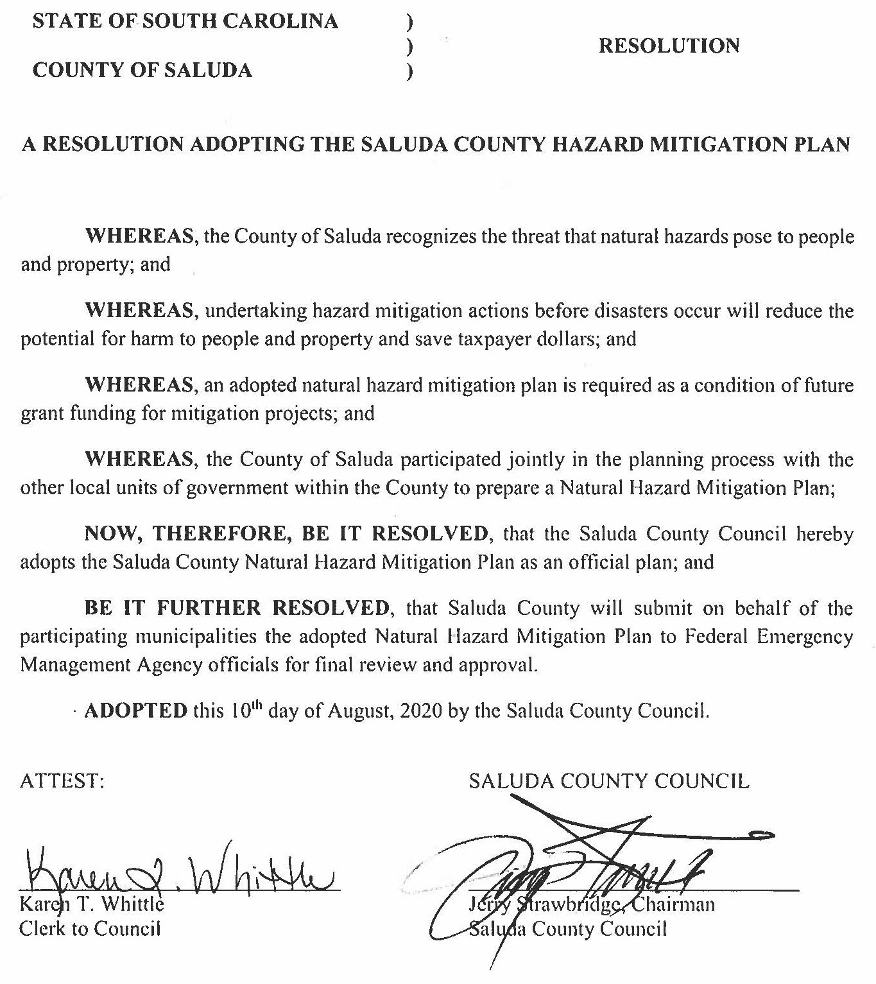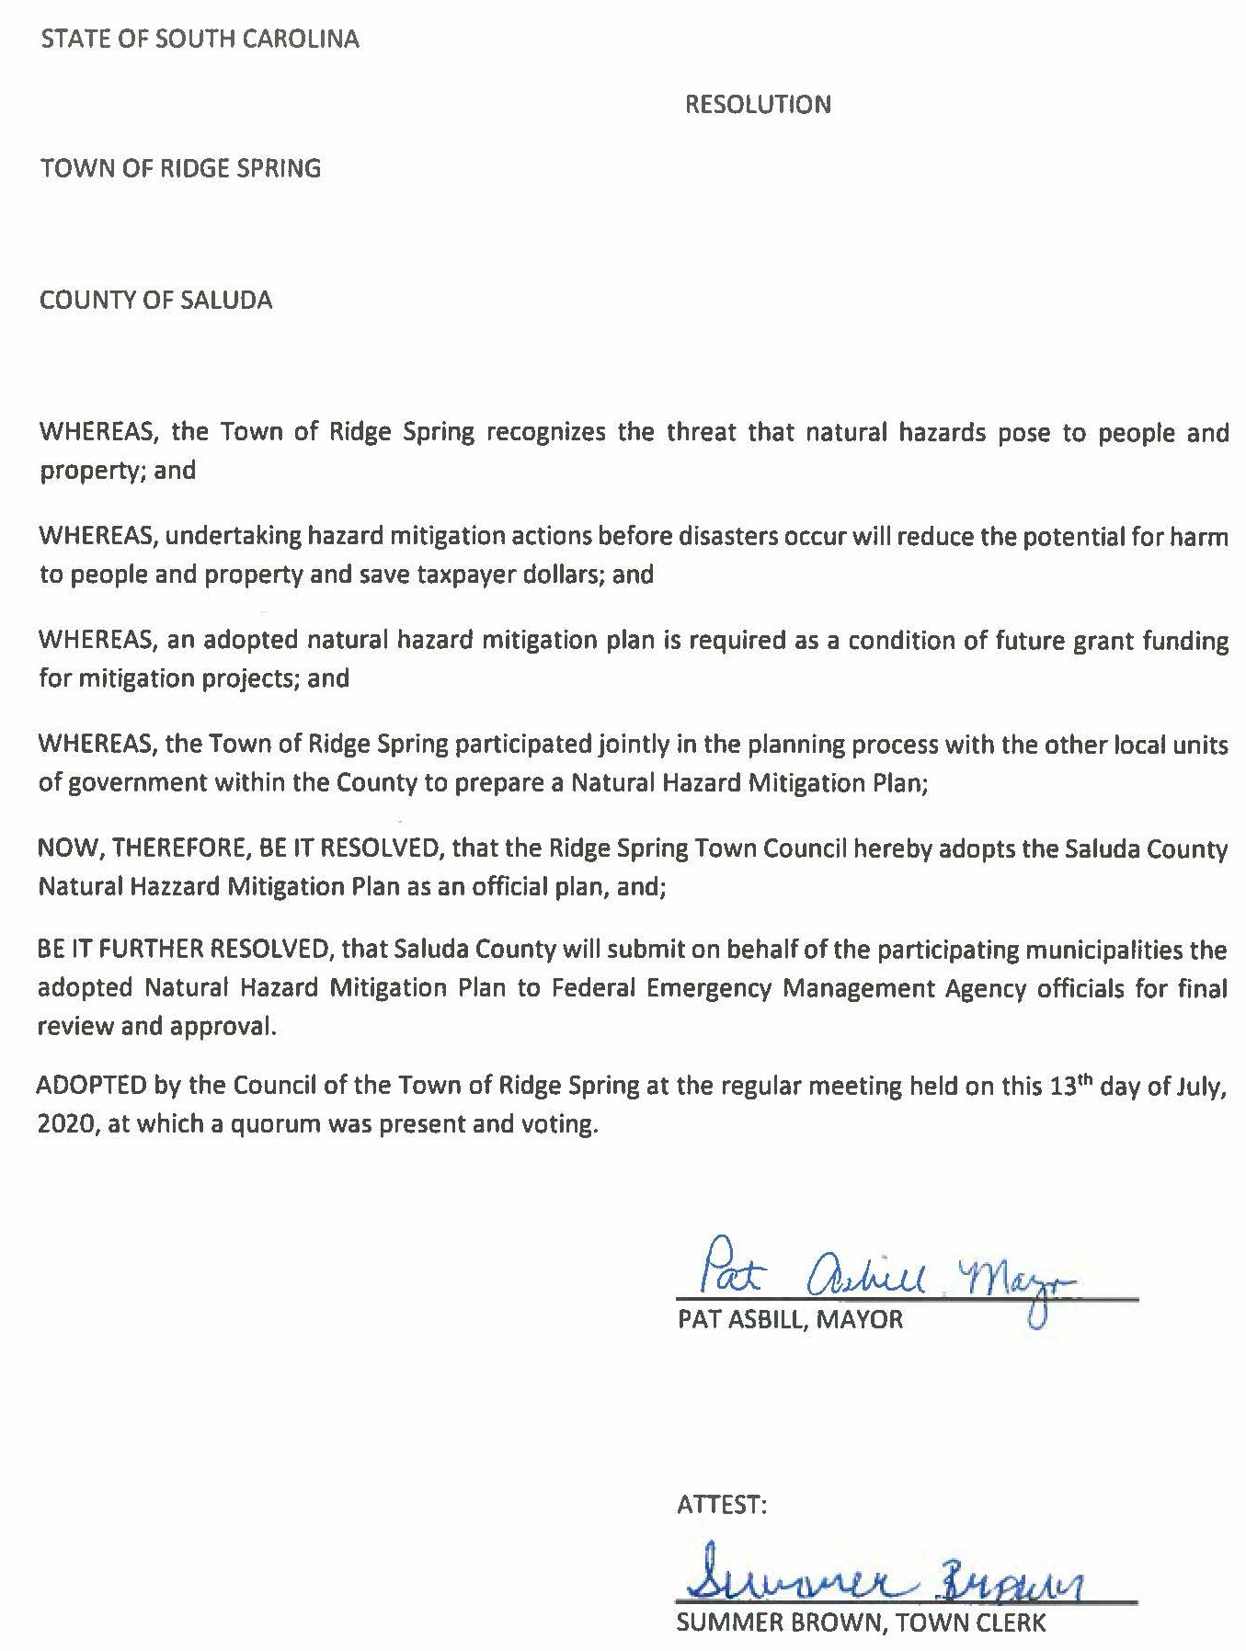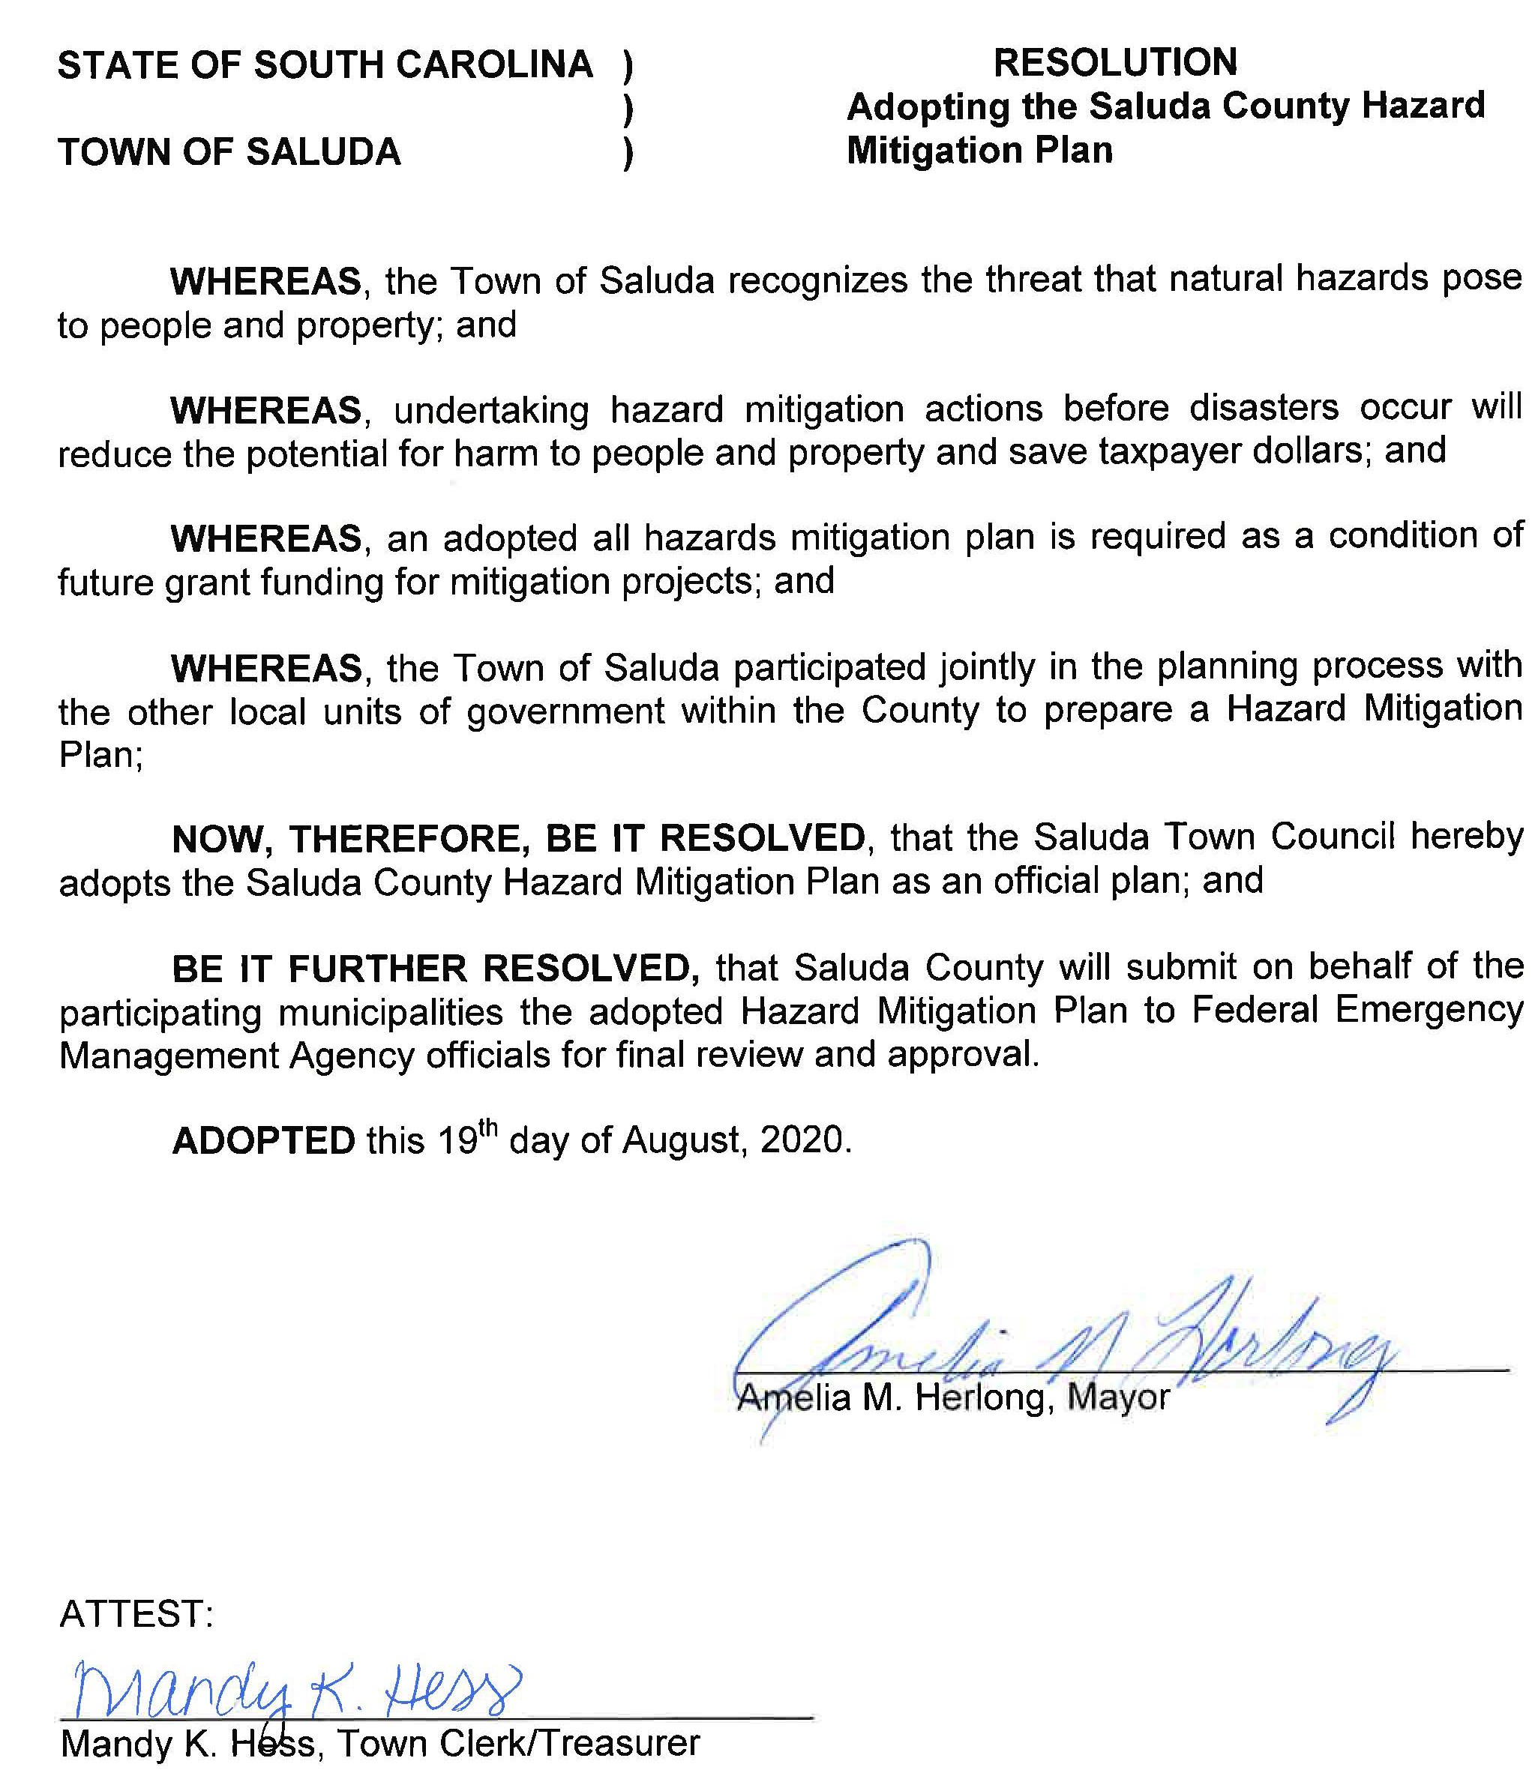

## Appendix 2: Declared Disasters

Source: [www.FEMA.gov](http://www.FEMA.gov/)

|  |  |  |  |
| --- | --- | --- | --- |
| **Year** | **Date** | **Declaration** | **Disaster** |
| 2024 | 9/29 | DR-4829 | South Carolina Hurricane Helene |
| 2022 | 11/21 | DR-4677 | South Carolina Hurricane Ian |
| 2020 | 3/27 | DR-4492 | South Carolina COVID-19 Pandemic |
| 2017 | 10/16 | DR-4346 | South Carolina Hurricane Irma |
| 2015 | 10/3 | DR-4241 | South Carolina Severe Storms and Flooding |
| 2014 | 3/12 | DR-4166 | South Carolina Severe Winter Storm |
| 2014 | 2/12 | EM-3369 | South Carolina Severe Winter Storm |
| 2005 | 9/10 | EM-3233 | South Carolina Hurricane Katrina Evacuation |
| 2004 | 2/13 | DR-1509 | South Carolina Severe Ice Storm |
| 2000 | 1/31 | DR-1313 | South Carolina Winter Storms |
| 1977 | 8/4 | EM-3047 | South Carolina Drought |

## Appendix 3: Historical Events (1960 – 2020)

Included in this appendix are the historical events utilized for conducting the Hazard Vulnerability Analysis. For purposes of this analysis, lightning and wind events were combined with severe thunderstorms, as these events have similar effects and often accompany one another. All dollar amounts are adjusted to 2022 dollar amounts.

|  |  |  |  |  |  |
| --- | --- | --- | --- | --- | --- |
| **HAZARD TYPE** | **YEAR** | **PROPERTY DAMAGE** | **CROP DAMAGE** | **FATALITIES** | **INJURIES** |
| Coastal | 1983 | $7,719.06 | $771.91 | 0 | 0 |
| Drought | 1977 | $2537.36 | $253,734.62 | 0 | 0 |
| Drought | 1978 | $283.02 | $7,075.02 | 0 | 0 |
| Drought | 1984 | $0.00 | $2,959.84 | 0 | 0 |
| Drought | 1986 | $293,395.65 | $2,837,093.35 | 0 | 0 |
| Drought | 1988 | $2,889.04 | $34,711.62 | 0 | 0 |
| Drought | 1993 | $5,618,474.77 | $5,618,474.77 | 0 | 0 |
| Drought | 1994 | $0.00 | $2,087,076.69 | 0 | 0 |
| Drought | 1995 | $0.00 | $807,155.82 | 0 | 0 |
| Flooding | 1964 | $992.06 | $992.06 | 0 | 0 |
| Flooding | 1966 | $9491.58 | $9491.58 | 0 | 0 |
| Flooding | 1973 | $12,968.86 | $549,386.70 | 0 | 0 |
| Flooding | 1975 | $3,223.26 | $36,805.37 | 0 | 0 |
| Flooding | 1976 | $54046.84 | $54,046.84 | 0 | 0 |
| Flooding | 1978 | $28,300.00 | $2.37 | 0 | 0 |
| Flooding | 1980 | $5,598.20 | $3,918.75 | 0 | 0 |
| Flooding | 1983 | $9,539.96 | $790.12 | 0 | 0 |
| Flooding | 1984 | $3,538.20 | $19.73 | 0 | 0.02333 |
| Flooding | 1993 | $21,282.11 | $425,653.77 | 0 | 0 |
| Flooding | 2015 | $2,387.38 | $0.00 | 0 | 0 |
| Flooding | 2016 | $40,521.42 | $0.00 | 0 | 0 |
| Flooding | 2017 | $226.86 | $226.86 | 0 | 0 |
| Hail | 1960 | $682.75 | $0.00 | 0 | 0 |
| Hail | 1962 | $936.84 | $0.00 | 0 | 0 |
| Hail | 1963 | $0.00 | $100,498.86 | 0 | 0 |
| Hail | 1965 | $650.87 | $32.54 | 0 | 0 |
| Hail | 1973 | $399.25 | $452.36 | 0 | 0.03667 |
| Hail | 1974 | $2,829.14 | $2,829.14 | 0 | 0 |
| Hail | 1975 | $5,261.46 | $27,548.81 | 0 | 0.1 |
| Hail | 1977 | $169.16 | $1,691.57 | 0 | 0.00667 |
| Hail | 1982 | $89,407.44 | $89,529.61 | 0 | 0.05 |
| Hail | 1984 | $983.09 | $317.21 | 0 | 0 |
| Hail | 1985 | $3,492.85 | $835.58 | 0 | 0 |
| Hail | 1988 | $11.95 | $0.00 | 0 | 0 |
| Hail | 1993 | $4,894.89 | $0.00 | 0 | 0 |
| Hail | 1999 | $3,396,449.66 | $3,396,449.66 | 0 | 2 |
| Hail | 2011 | $5,031.13 | $7,546.69 | 0 | 0 |
| Hail | 2012 | $12,322.80 | $12,322.80 | 0 | 0 |

|  |  |  |  |  |  |
| --- | --- | --- | --- | --- | --- |
| **HAZARD TYPE** | **YEAR** | **PROPERTY DAMAGE** | **CROP DAMAGE** | **FATALITIES** | **INJURIES** |
| Hail | 2015 | $28,648.50 | $0.00 | 0 | 0 |
| Hail | 2017 | $113.43 | $113.43 | 0 | 0 |
| Hail | 2019 | $120.09 | 120.09 |  |  |
| Hail | 2020 | $21.58 | 118.73 |  |  |
| Heat | 1976 | $540.49 | $5,404.70 | 0 | 0 |
| Heat | 1977 | $2,537.36 | $253,734.62 | 0 | 0 |
| Heat | 1978 | $235.85 | $2,358.34 | 0 | 0 |
| Heat | 1985 | $0.00 | $285,805.17 | 0 | 0 |
| Heat | 1993 | $5,618,474.77 | $7,746,684.91 | 0 | 0 |
| Hurricane/Tropical Storm | 1964 | $10,912.30 | $10,912.30 | 0 | 0 |
| Hurricane/Tropical Storm | 1968 | $883.73 | $88.37 | 0 | 0 |
| Hurricane/Tropical Storm | 1972 | $735.74 | $7,357.11 | 0 | 0 |
| Hurricane/Tropical Storm | 1979 | $847,180.05 | $0.00 | 0 | 0 |
| Hurricane/Tropical Storm | 1995 | $403,577.90 | $4,035.77 | 0 | 0 |
| Lightning | 1965 | $1,301.75 | $32.54 | 0 | 0 |
| Lightning | 1972 | $0.00 | $0.00 | 0 | 0.5 |
| Lightning | 1973 | $511.36 | $463.57 | 0 | 0.03667 |
| Lightning | 1974 | $10,091.08 | $2,658.44 | 0 | 0.075 |
| Lightning | 1975 | $11,177.29 | $27,600.46 | 0 | 0.11667 |
| Lightning | 1976 | $3,453.00 | $34.54 | 0 | 0 |
| Lightning | 1977 | $2,706.52 | $1,716.95 | 0 | 0.00667 |
| Lightning | 1982 | $89,393.87 | $89,393.87 | 0 | 0.05 |
| Lightning | 1983 | $3,572.81 | $15.44 | 0 | 0 |
| Lightning | 1984 | $2,304.93 | $74.00 | 0 | 0 |
| Lightning | 1988 | $119,579.14 | $0.00 | 0 | 0 |
| Severe Storm/Thunder Storm | 1961 | $675.90 | $0.00 | 0 | 0 |
| Severe Storm/Thunder Storm | 1964 | $117,455.28 | $127,375.52 | 0.02 | 0 |
| Severe Storm/Thunder Storm | 1965 | $325.44 | $97,627.46 | 0 | 0 |
| Severe Storm/Thunder Storm | 1966 | $474.60 | $0.00 | 0 | 0 |
| Severe Storm/Thunder Storm | 1967 | $92,073.80 | $920.77 | 0 | 0 |
| Severe Storm/Thunder Storm | 1968 | $63,515.69 | $6.34 | 0 | 0 |
| Severe Storm/Thunder Storm | 1971 | $25,690.50 | $25,310.82 | 0 | 0 |
| Severe Storm/Thunder Storm | 1972 | $0.00 | $0.00 | 0 | 0.5 |
| Severe Storm/Thunder Storm | 1973 | $6,154.68 | $549,390.96 | 0 | 0 |
| Severe Storm/Thunder Storm | 1974 | $220.72 | $0.00 | 0 | 0 |
| Severe Storm/Thunder Storm | 1975 | $6,140.07 | $36,832.31 | 0 | 0.01667 |
| Severe Storm/Thunder Storm | 1977 | $329.87 | $22.38 | 0 | 0 |
| Severe Storm/Thunder Storm | 1982 | $89,407.44 | $89,529.61 | 0 | 0.05 |
| Severe Storm/Thunder Storm | 1983 | $14,888.86 | $1,045.05 | 0 | 0 |
| Severe Storm/Thunder Storm | 1984 | $4,278.16 | $93.73 | 0 | 0.02333 |
| Severe Storm/Thunder Storm | 1985 | $714.52 | $0.72 | 0 | 0 |
| Severe Storm/Thunder Storm | 1988 | $597.90 | $0.00 | 0 | 0 |
| Severe Storm/Thunder Storm | 1989 | $11,978.65 | $0.00 | 0 | 0 |
| Severe Storm/Thunder Storm | 1995 | $46,411.46 | $0.00 | 0 | 0 |
| Severe Storm/Thunder Storm | 2002 | $4,718.03 | $0.00 | 0 | 0 |
| Severe Storm/Thunder Storm | 2003 | $1,537.63 | $0.00 | 0 | 0 |

|  |  |  |  |  |  |
| --- | --- | --- | --- | --- | --- |
| **HAZARD TYPE** | **YEAR** | **PROPERTY DAMAGE** | **CROP DAMAGE** | **FATALITIES** | **INJURIES** |
| Severe Storm/Thunder Storm | 2006 | $7,367.82 | $0.00 | 0 | 0 |
| Severe Storm/Thunder Storm | 2007 | $3,411.33 | $0.00 | 0 | 0 |
| Severe Storm/Thunder Storm | 2008 | $0.00 | $131.41 | 0 | 0 |
| Severe Storm/Thunder Storm | 2009 | $659.39 | $13,187.67 | 0 | 0 |
| Severe Storm/Thunder Storm | 2010 | $55,791.83 | $1,297.49 | 0 | 0 |
| Severe Storm/Thunder Storm | 2011 | $194,327.35 | $0.00 | 0 | 0 |
| Severe Storm/Thunder Storm | 2012 | $40,049.12 | $0.00 | 0 | 0 |
| Severe Storm/Thunder Storm | 2013 | $7,894.20 | $0.00 | 0 | 0 |
| Severe Storm/Thunder Storm | 2014 | $8,365.74 | $0.00 | 0 | 0 |
| Severe Storm/Thunder Storm | 2015 | $18,203.74 | $0.00 | 0 | 0 |
| Tornado | 1992 | $756,212.37 | $756,212.37 | 0 | 2.25 |
| Tornado | 1998 | $86,786.58 | $0.00 | 0 | 0 |
| Tornado | 2004 | $0.00 | $0.00 | 0 | 1 |
| Wildfire | 1966 | $94,915.59 | $0.00 | 0 | 0 |
| Wildfire | 1985 | $28,866.35 | $314,385.78 | 0 | 0 |
| Wind | 1960 | $682.75 | $0.00 | 0 | 0 |
| Wind | 1961 | $2,733.02 | $0.00 | 0 | 0 |
| Wind | 1962 | $936.84 | $0.00 | 0 | 0 |
| Wind | 1964 | $992.06 | $0.00 | 0 | 0.02 |
| Wind | 1965 | $650.87 | $32.54 | 0 | 0 |
| Wind | 1966 | $474.60 | $0.00 | 0 | 0 |
| Wind | 1969 | $7,709.11 | $7.71 | 0.02 | 0.04 |
| Wind | 1971 | $25,690.50 | $25,310.82 | 0 | 0 |
| Wind | 1973 | $1,442.55 | $404.57 | 0 | 0.03667 |
| Wind | 1974 | $12,296.26 | $3,210.25 | 0 | 0.075 |
| Wind | 1975 | $11,036.33 | $27,604.33 | 0 | 0.11667 |
| Wind | 1976 | $3,453 | $34.54 | 0 | 0 |
| Wind | 1977 | $3,543.88 | $1,843.82 | 0 | 0.00667 |
| Wind | 1978 | $23,583.32 | $2.37 | 0 | 0 |
| Wind | 1980 | $5,598.34 | $186.62 | 0.04 | 0 |
| Wind | 1981 | $3,383.14 | $3.39 | 0 | 0 |
| Wind | 1982 | $89,407.44 | $89,529.61 | 0 | 0.05 |
| Wind | 1983 | $20,436.96 | $1,080.25 | 0 | 0 |
| Wind | 1984 | $3,252.30 | $366.46 | 0 | 0.02333 |
| Wind | 1985 | $2,800.90 | $143.63 | 0 | 0 |
| Wind | 1986 | $12,907.13 | $0.00 | 0 | 0 |
| Wind | 1988 | $1,009.64 | $0.00 | 0 | 0 |
| Wind | 1989 | $14,458.71 | $2.49 | 0 | 0 |
| Wind | 1993 | $5,547.53 | $0.00 | 0 | 0 |
| Wind | 1995 | $55,693.75 | $0.00 | 0 | 0 |
| Wind | 2002 | $4,718.03 | $0.00 | 0 | 0 |
| Wind | 2003 | $1,537.63 | $0.00 | 0 | 0 |
| Wind | 2006 | $7,367.82 | $0.00 | 0 | 0 |
| Wind | 2007 | $3,411.33 | $0.00 | 0 | 0 |
| Wind | 2008 | $19,711.12 | $6,701.78 | 0 | 0 |
| Wind | 2009 | $19,122.13 | $13,187.67 | 0 | 0 |

|  |  |  |  |  |  |
| --- | --- | --- | --- | --- | --- |
| **HAZARD TYPE** | **YEAR** | **PROPERTY DAMAGE** | **CROP DAMAGE** | **FATALITIES** | **INJURIES** |
| Wind | 2010 | $55,791.83 | $1,297.49 | 0 | 0 |
| Wind | 2011 | $194,327.35 | $0.00 | 0 | 0 |
| Wind | 2012 | $40,049.12 | $0.00 | 0 | 0 |
| Wind | 2013 | $7,894.20 | $0.00 | 0 | 0 |
| Wind | 2014 | $14,341.26 | $0.00 | 0 | 0 |
| Wind | 2015 | $18,203.74 | $0.00 | 0 | 0 |
| Wind | 2016 | $1,157.75 | $0.00 | 0 | 0 |
| Winter Weather | 1960 | $13,654.63 | $0.00 | 0 | 0 |
| Winter Weather | 1961 | $11,313.76 | $1,028.56 | 0 | 0 |
| Winter Weather | 1963 | $100,498.86 | $10,049.91 | 0 | 0.57 |
| Winter Weather | 1964 | $0.00 | $992,020.52 | 0 | 0 |
| Winter Weather | 1966 | $143,729.19 | $94,915.59 | 0.18 | 0 |
| Winter Weather | 1968 | $63,515.69 | $6.34 | 0 | 0 |
| Winter Weather | 1969 | $89,720.91 | $8,201,186.26 | 0.02 | 0.04 |
| Winter Weather | 1970 | $800.58 | $15.90 | 0 | 0 |
| Winter Weather | 1971 | $25,310.82 | $25,310.82 | 0 | 0 |
| Winter Weather | 1972 | $0.00 | $384,575.15 | 0 | 0 |
| Winter Weather | 1973 | $761,889.67 | $693,319.59 | 0.2 | 0 |
| Winter Weather | 1974 | $7,357.47 | $0.00 | 0 | 0 |
| Winter Weather | 1975 | $0.00 | $5,716.12 | 0 | 0 |
| Winter Weather | 1977 | $1,014.98 | $1,014.98 | 0 | 0 |
| Winter Weather | 1979 | $691,863.87 | $1,073.13 | 0 | 0 |
| Winter Weather | 1980 | $41,131.35 | $4,105.36 | 0 | 0 |
| Winter Weather | 1982 | $8,741.92 | $3,984,369.73 | 0 | 0.09 |
| Winter Weather | 1983 | $37,205.78 | $3,118,831.46 | 0.63 | 0 |
| Winter Weather | 1984 | $4,862.57 | $486.25 | 0 | 0 |
| Winter Weather | 1985 | $29,580.87 | $5,745.42 | 0.33 | 0 |
| Winter Weather | 1986 | $2,805.91 | $5,639.88 | 0 | 0 |
| Winter Weather | 1987 | $6,315.71 | $4,095.27 | 0 | 0 |
| Winter Weather | 1988 | $26,255.45 | $62.95 | 0 | 0 |
| Winter Weather | 1989 | $40,173.95 | $0.00 | 0 | 0 |
| Winter Weather | 1990 | $0.00 | $235,291.78 | 0 | 0 |
| Winter Weather | 1992 | $36,010.11 | $889,172.79 | 0 | 0 |
| Winter Weather | 1993 | $69,926.91 | $69,926.91 | 0 | 0 |
| Winter Weather | 2014 | $7,170.63 | $0.00 | 0 | 0 |
| **TOTAL** | | **$21,497,658.63** | **$45,709,450.15** | **1.44** | **7.91** |

*Data Source: University of South Carolina Hazards and Vulnerability Research Institute*

## Appendix 4: Planning Committee Agendas, Minutes and Sign-In Sheets

For the purposes of developing this new plan, the Saluda County Hazard Mitigation Planning Committee held meetings as indicated in the below table. Meeting agendas, minutes, and sign-in sheets for each of these meetings can be found on the following pages.

|  |  |  |
| --- | --- | --- |
| Date | Time | Location |
| August 22, 2024 | 10:00 AM | Saluda County EOC |
| September 16, 2024 | 10:00 AM | Saluda County EOC |
| January 15, 2025 | 1:00 PM | Saluda County EOC |

## Saluda County Emergency Management Division

#### Hazard Mitigation Planning Committee Agenda

August 22nd, 2024

10:00 AM

Saluda County Emergency Operations Center

* Welcome and Introductions
* Overview of Hazard Mitigation Planning
* Review of 2020 Plan
* Review Mitigation Actions for 2025 Plan
* Next Steps
* Adjourn

**\*\*Next Committee Meeting will be held on September 16th, 2024 at 10:00 AM at the Saluda County Emergency Operations Center\*\***

**Saluda County Hazard Mitigation Planning Committee**

August 22nd, 2024

Saluda County Emergency Operations Center Meeting Minutes

The meeting was called to order at 10:00 am by Saluda County Emergency Management Director Josh Morton.

The committee was asked if there were any issues identified upon reviewing the most recent draft.

Director Morton provided a brief overview of hazard mitigation and the mitigation planning process and discussed the sections of the plan. A copy of the mitigation actions from the 2020 plan was distributed to jurisdictions present at the meeting for review prior to the September 16th meeting.

There was a discussion regarding the 2022 Mitigation Guidance update and the potential impacts on our upcoming plan update.

The remainder of the meeting focused on going over the updated hazard maps and discussing social vulnerability.

All members were encouraged to attend the next meeting on September 16th. The meeting was adjourned at 10:45 am.

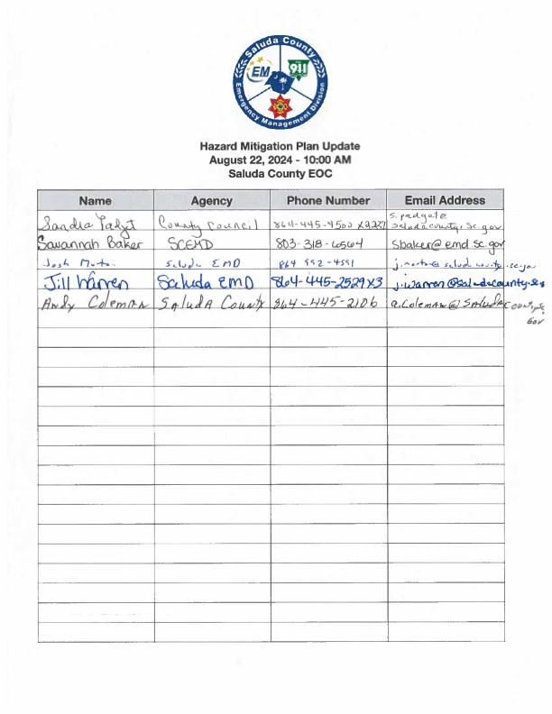

**Saluda County Emergency Management Division Hazard Mitigation Planning Committee Agenda**

September 16th, 2024

10:00 AM

Saluda County Emergency Operations Center

* Welcome and Introductions
* Overview of Mitigation Planning
* Review of 2020 Plan
* Discussion of Hazard Analysis Update
* Update Mitigation Actions
* Additional Discussion
* Adjourn

**\*\*Next Committee Meeting will be held on October 16th, 2024 at 10:00 AM**

**at the Saluda County Emergency Operations Center\*\***

## Saluda County Hazard Mitigation Planning Committee

September 16th, 2024

Saluda County Emergency Operations Center Meeting Minutes

The meeting was called to order at 10:00 am by Saluda County Emergency Management Director Josh Morton.

The committee was asked if there were any issues identified upon reviewing the most recent draft.

Director Morton provided a brief overview of hazard mitigation and the mitigation planning process and discussed the sections of the plan. A copy of the mitigation actions from the 2020 plan was distributed to those jurisdictions that had not been present at the August meeting for review.

There was additional discussion regarding the 2022 Mitigation Guidance update and the potential impacts on our upcoming plan update.

The remainder of the meeting was dedicated to the discussion of mitigation actions.

An additional meeting is planned for October 16th, 2024, at 10:00 AM. The team is tentatively considering December 9th, 2024, for the public hearing.

The meeting was adjourned at 10:35 am.

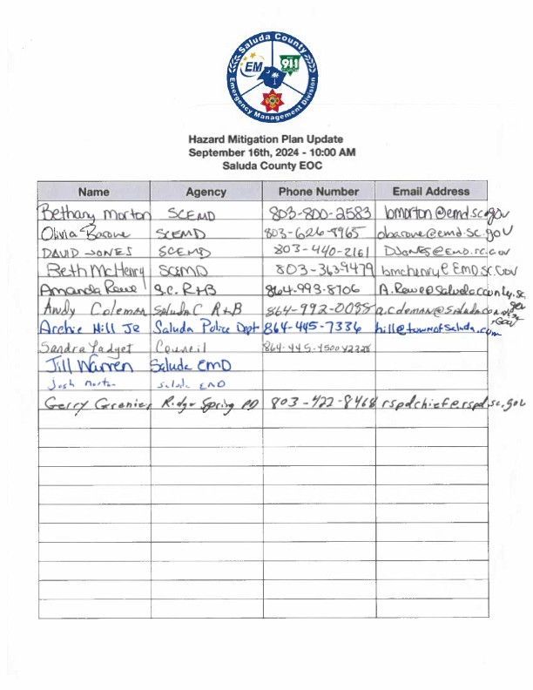

**Saluda County Emergency Management Division Hazard Mitigation Planning Committee Agenda**

January 15th, 2024

1:00 PM

Saluda County Emergency Operations Center

* Welcome and Introductions
* Overview of Mitigation Planning
* Overview of Plan Updates
* Discussion of Hazard Analysis Update
* Update Mitigation Actions
* Additional Discussion
* Adjourn

**\*\*Public Hearing Anticipated on May 10th, 2025 at 6:00 PM\*\***

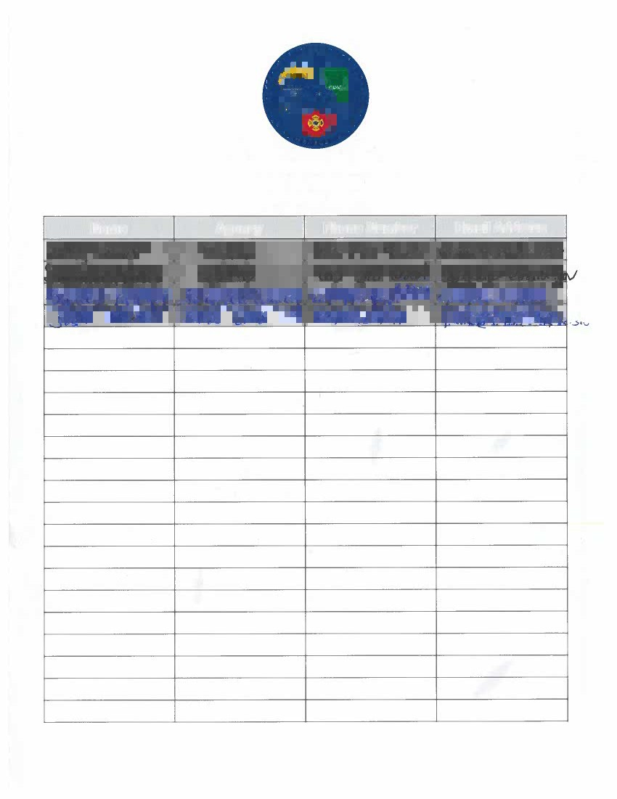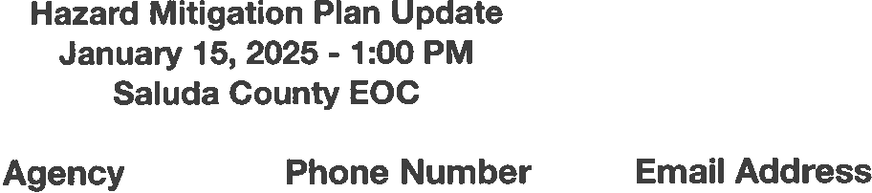

## Saluda County Hazard Mitigation Planning Committee

January 15th, 2025

Saluda County Emergency Operations Center Meeting Minutes

The meeting was called to order at 1:00 pm by Saluda County Emergency Management Director Josh Morton.

The committee reviewed and discussed updates to the most recent draft.

There was additional discussion regarding the 2022 Mitigation Guidance update and the potential impacts on our upcoming plan update.

The remainder of the meeting was dedicated to the discussion of mitigation actions. The team is tentatively considering May 12th, 2025, for the public hearing.

The meeting was adjourned at 1:30 pm.

**Appendix 5: Public Hearings**

**Appendix 6: Public Notices**

## References

1 Disaster Mitigation Act of 2000 § 101, Pub. L. No. 106-390, 114 Stat. 1553.

2 Disaster Mitigation Act of 2000 § 322, Pub. L. No. 106-390, 114 Stat. 1558.

3 Mitigation Planning, 44 CFR §201.6 (b) (2002).

4 United States Census Bureau. (n.d.). *Saluda County QuickFacts from the US Census Bureau*. Retrieved December 17, 2024, from <http://quickfacts.census.gov/qfd/states/45/45081.html>

5 United States Census Bureau. (n.d.). *Saluda County QuickFacts from the US Census Bureau*. Retrieved December 17, 2024, from <http://quickfacts.census.gov/qfd/states/45/45081.html>

6 United States Census Bureau. (n.d.). *Saluda County QuickFacts from the US Census Bureau*. Retrieved December 17, 2024, from <http://quickfacts.census.gov/qfd/states/45/45081.html>

7 United States Census Bureau. (n.d.). *Saluda County QuickFacts from the US Census Bureau*. Retrieved December 17, 2024, from <http://quickfacts.census.gov/qfd/states/45/45081.html>

8 Social Vulnerability Index. (n.d.). *Social Vulnerability Index*. Retrieved August 8, 2019, from http:// <http://artsandsciences.sc.edu/geog/hvri/sites/sc.edu.geog.hvri/files/attachments/SoVI_10_14_Website.pdf>

9 South Carolina Hazard Mitigation Plan. (2013, October 1). Retrieved July 21, 2014, from <http://www.scemd.org/files/Mitigation/State_Hazard_Mitigation_Plan/1_SHMP_FINAL_2013.pdf>

10 Hazards & Vulnerability Research Institute (2018). The Spatial Hazard Events and Losses Database for the United States, Version 17.0 [Online Database]. Columbia, SC: University of South Carolina. Available from [http://www.sheldus.org](http://www.sheldus.org/)

11 NOAA’s National Climatic Data Center (NCDC), (n.d.). *Historical Palmer Drought Indices.* Retrieved February 18, 2015. <http://www.ncdc.noaa.gov/temp-and-precip/drought/historical-palmers/psi/200901-201411>

12 FEMA. (n.d.). *Why Earthquakes Occur*. Retrieved July 29, 2014, from <http://www.fema.gov/earthquake/why-> earthquakes-occur

13 Earthquake Glossary - Richter scale. (n.d.). Retrieved September 15, 2014, from <http://earthquake.usgs.gov/learn/glossary/?term=Richter>scale

14 Definitions | FEMA.gov. (n.d.). *Definitions | FEMA.gov*. Retrieved July 2, 2014, from <http://www.fema.gov/national-flood-insurance-program/definitions>

15 NOAA’s National Climatic Data Center (NCDC), (n.d.). *Storm Events Database.* Retrieved February 18, 2015 from [http://www.ncdc.noaa.gov/stormevents/.](http://www.ncdc.noaa.gov/stormevents/)

16 About the National Flood Insurance Program. (n.d.). Retrieved August 5, 2014, from https://[www.floodsmart.gov/floodsmart/pages/about/nfip_overview.jsp](http://www.floodsmart.gov/floodsmart/pages/about/nfip_overview.jsp)

17 All About Hail - weather.com. (2008, August 11). *The Weather Channel*. Retrieved July 18, 2014, from <http://www.weather.com/outlook/weather-news/news/articles/iwitness-hail-slideshow_2011-08-11>

18 NOAA National Severe Storms Laboratory. (n.d.). *NSSL: Severe Weather 101: Hail*. Retrieved July 16, 2014, from <http://www.nssl.noaa.gov/education/svrwx101/hail/>

19 NOAA’s National Climatic Data Center (NCDC), (n.d.). *Storm Events Database.* Retrieved February 18, 2015 from [http://www.ncdc.noaa.gov/stormevents/.](http://www.ncdc.noaa.gov/stormevents/)

20 NOAA National Severe Storms Laboratory. (n.d.). *NSSL: Severe Weather 101*. Retrieved July 29, 2014, from <http://nssl.noaa.gov/primer/tstorm/sts_basics.html>

21 Why One Inch Hail Criterion?. (2010, January 5). *National Weather Service*. Retrieved July 29, 2014, from <http://www.nws.noaa.gov/oneinchhail/>

22 NOAA’s National Climatic Data Center (NCDC), (n.d.). *Storm Events Database.* Retrieved February 18, 2015 from [http://www.ncdc.noaa.gov/stormevents/.](http://www.ncdc.noaa.gov/stormevents/)

23 NOAA's National Climatic Data Center (NCDC). (n.d.). *National Climatic Data Center (NCDC)*. Retrieved July 1, 2014, from <http://www.ncdc.noaa.gov/>

24 South Carolina Forestry Commission Wildfire in S.C.. (n.d.). *SCFC Wildfire in S.C.*. Retrieved July 29, 2014, from <http://www.state.sc.us/forest/refwild.htm>

25 Winter Storms & Extreme Cold. (2014, January 8). *Home*. Retrieved July 29, 2014, from <http://www.ready.gov/winter-weather>

26 Disaster Declarations | FEMA.gov. (n.d.). Retrieved August 8, 2019, from <http://www.fema.gov/disaster>

27 FEMA. (2013). *Local Mitigation Planning Handbook.* Retrieved July 30, 2014, from <http://www.fema.gov/media-library/assets/documents/31598>

28 *Dictionary of Architecture and Construction*. (2006). : McGraw-Hill Companies, Inc..

29 Capital Improvement Planning. (n.d.). *Capital Improvements*. Retrieved July 31, 2014, from <http://www.ncpc.gov/ncpc/Main(T2)/Planning(Tr2)/CapitalImprovements.html>

30 Building Code. (n.d.) *WordNet 3.0, Farlex clipart collection*. (2003-2008). Retrieved August 4 2014 from [http://www.thefreedictionary.com/building+code](http://www.thefreedictionary.com/building%2Bcode)

31 Flood Damage Prevention Ordinance (June 13, 2007). Saluda County, South Carolina. Ordinance # 05-07.

32 Gifis, S. (2010). Zoning. *Law Dictionary* (Sixth ed. ). : Barron's Educational Series, Inc..

33 *Developing and maintaining emergency operations plans: Comprehensive Preparedness Guide (CPG) 101* (Version 2.0.). (2010). Appendix B: List of Acronyms and Glossary. Washington, D.C.: Dept. of Homeland Security. Federal Emergency Management Agency.

34 FEMA. (2013). *Mitigation Ideas: A Resource for Reducing Risk to Natural Hazards.* Retrieved July 15, 2014 from <http://www.fema.gov/media-library/assets/documents/30627?id=6938>

35 Mitigation Planning, 44 CFR §201.3 (d) (2) (2002).